*Master-Thesis*

*/*

*Masterarbeit*

**A study on the modeling of the distribution automation systems using Petri Nets**

/

**Eine Untersuchung zur Modellierung der Verteilnetzautomationssysteme mit Petri Netz**

*Huiyuan Xiao*

*Studienrichtung:*

Elektrotechnik und Informationstechnik

Professor: Prof. Antonello Monti

Supervisor: Abhinav Sadu

Aachen, den_____________ __________________________

Der 1. Prüfer

Aachen, den_____________ __________________________

Der Vorsitzende des Prüfungsausschusses

**Table of Contents**

1. Introduction 11

1.1. Motivation 11

1.2. Structure of Work 12

2. IDE4L project 13

2.1. Overview 13

2.2. IDE4L project automation concept and architecture 14

2.3. The major Use Cases 17

3. Petri Net 20

3.1. Origin and Development of Petri Net 20

3.2. Basics of Petri Net 20

3.2.1. Definition of Petri net 20

3.2.2. Structure of Petri Net 21

3.2.3. Mathematic representation 22

3.2.4. Operation rules of Petri Net 22

3.2.5. Property of Petri Net 23

3.2.6. Basic logic connections in Petri Net 24

3.3. Extensions of Petri Net 24

4. Software platforms for Petri Net 26

4.1. Overview 26

4.2. TIMENET 4.0 27

4.3. ORIS 28

4.4. PIPE 29

4.5. Summary 29

5. Modeling of IDE4L for survivability evaluation using SCPN 30

5.1. MVPC 31

5.2. MVRTM 32

5.3. MVSE 33

5.4. MVSF 34

5.5. NDU 35

5.6. CCPC 36

5.7. Whole system 37

5.8. Theoretical basis behind qualitative analysis results 41

6. Modeling of IDE4L for dependability evaluation using STPN 42

6.1. IDE4L automation frame 42

6.2. Mathematical basis 44

6.3. Centralized automation vs. IDE4L 48

6.4. Approaches to improve distribution automation system dependability 49

6.4.1. DMS backup-strategy 49

6.4.2. Bad/Missing data detection/correction 50

6.4.3. Separate single IED into control and monitoring IEDs 51

6.4.4. PSAU migration 52

6.4.5. PSAU double virtualization 54

6.5. Analysis of the results 55

7. Conclusions 59

8. Bibliography 60

9. Appendix 61

9.1. PIPE installation and functions 61

9.1.1. PIPE installation 61

9.1.2. Petri Nets creating 61

9.1.3. Petri net analysis 67

9.2. ORIS installation and functions 69

9.2.1. ORIS installation 69

9.2.2. Petri Nets creating 69

9.2.3. Petri Nets analysis 72

**List of Figures**

Fig.1 An overview of the IDE4L automation solution [1] 13

Fig.2 Interoperability layers of IDE4L [5] 15

Fig.3 Comparison between centralized and IDE4L approach [2] 16

Fig.4 IDE4L architecture [3] 16

Fig.5 Implementation of Substation Automation Unit [4] 17

Fig.6 HLUCs schematic [5] 18

Fig.7 A simple Petri Net 21

Fig.8 Basic logic connections represented by Petri Net 24

Fig.9 a sample screen shot of the interface [8] 27

Fig.10 ORIS tool [9] 28

Fig.11 PIPE interface 29

Fig.12 IDE4L overall automation architecture mapped on Smart Grid Plane [5] 30

Fig.13 Simple PN of Medium Voltage Network Power Control (MVPC) 31

Fig.14 Scenarios-oriented PN of Medium Voltage Network Real Time Monitoring (MVRTM) 32

Fig.15 Simple PN of Medium Voltage Network Real Time Monitoring (MVRTM) 33

Fig.16 Simple PN of Real-Time Medium Voltage Network State Estimation (MVSE) 33

Fig.17 Simple PN of Medium Voltage Network State Forecasting (MVSF) 34

Fig.18 Simple PN of Network Description Update (NDU) 35

Fig.19 Simple PN of Control Centre Power Control (CCPC) 36

Fig.20 Scenarios-oriented PN of the whole system 37

Fig.21 Congregation PN of the whole system 38

Fig.22 PIPE simulation results 40

Fig.23. The system model of smart grid [10] 42

Fig.24. Frame in IDE4L [5] 43

Fig.25 IDE4L architecture STPN 48

Fig.26 Centralized automation (CA) architecture STPN 48

Fig.27 DMS backup-strategy 49

Fig.28 Bad/Missing data detection/correction 50

Fig.29 Separate single IED into control and monitoring IEDs 51

Fig.30 PSAU migration 52

Fig.31 PSAU migration 52

Fig.32 Separate single IED into control and monitoring IEDs while PSAU migration 53

Fig.33 PSAU double virtualization with function backup or database backup 54

Fig.34: CA vs. IDE4L 55

Fig.35: DMS backup strategy 56

Fig.36: Bad/Missing data detection/correction 56

Fig.37:IED Separation 57

Fig.38: PSAU migration 57

Fig.39: PSAU double virtualization 58

Fig.40 PIPE-adding a token 62

Fig.41 PIPE- editing a token 62

Fig.42 PIPE-adding a place 63

Fig.43 PIPE- editing a place 64

Fig.44 PIPE- adding an arc 64

Fig.45 PIPE- editing an arc 65

Fig.46 PIPE- adding a rate parameter 65

Fig.47 PIPE- editing a rate parameter 66

Fig.48 PIPE- firing a transition 68

Fig.49 PIPE- Analysis modules 68

Fig.50 ORIS- adding a place 69

Fig.51 ORIS- editing a place 70

Fig.52 ORIS- editing a transition 70

Fig.53 ORIS- edited transition 71

Fig.54 ORIS- an example of Petri net 71

Fig.55 ORIS- regenerative transient analysis 73

Fig.56 ORIS- regenerative transient analysis board 74

Fig.57 ORIS- numerical results of regenerative transient analysis 75

Fig.58 ORIS- graphical results of regenerative transient analysis 75

Fig.59 ORIS- a simple PN 76

Fig.50 ORIS- graphical results of analysis with rewards 77

Fig.61 ORIS- graphical results of GSPN analysis 78

Fig.62 ORIS- log of GSPN analysis 78

Fig.63 ORIS- graphical results of analysis under enabling restriction 80

**List of Tables**

Table 1: IDE4L PUCs grouped by HLUCs and Clusters [5] 19

Table 2: Petri Nets tools comparison [7] 26

Table 3: Average tokens sorted descending 40

Table 4:Failure results 46

Table 5: Detailed failure probability of each use case 47

Table 6:The Firing Rates of Transitions [10] 47

Table 7: CA vs. IDE4L 49

Table 8: DMS backup-strategy 50

Table 9: Bad/Missing data detection/correction 50

Table 10: IED separation 51

Table 11: PSAU migration 52

Table 12: Separate single IED into control and monitoring IEDs while PSAU migration 53

Table 13: PSAU double virtualization 54

Kurzfassung:

Mit der höheren Netzdynamik und der zunehmenden Komplexität der Systemsteuerung sollte ein fortschrittliches Verteilungsautomatisierungssystem eingesetzt werden, um den normalen Betrieb des Systems zu gewährleisten. Diese Arbeit versucht, eine Machbarkeitsstudie zur Anwendung der Petri-Net-Theorie zur Modellierung und Analyse des Verteilungsautomationssystems durchzuführen. Die Flexibilität von SCPN und STPN wird durch eine detaillierte Studie über die 6 großen Anwendungsfälle auf der MV-Ebene von IDE4L in Komponenten- und Funktionsebene veranschaulicht. Der Leistungsvergleich verschiedener Architekturen und Schutzansätze überprüft die Vorteile und Notwendigkeit des IDE4L-Systems und die Möglichkeit der Verbesserung. Die Analysemethode kann auch in anderen Systemarchitekturen implementiert werden.

Abstract:

With the higher grid dynamics and increasing power system control complexity, advanced distribution automation system should be deployed to ensure the normal operation of the system. This thesis tries to complete a feasibility study on using Petri Net theory for modeling and analyzing the distribution automation system. The flexibility of SCPN and STPN is illustrated by a detailed study on the 6 major use cases at the MV level of IDE4L in component level and function level. The performance comparison of different architectures and protection approaches verify the advantages and necessity of the IDE4L system and the possibility of improvement. The analysis method can also be implemented in other system architecture.

1. Introduction
   1. Motivation

With the higher penetration of distributed generations (DGs) and increasing system control complexity due to interaction of huge number of actors in smart grid, Distribution Automation (DA) is needed at distribution level to enhance efficiency, reliability and quality of electric service. Distribution automation system is a complete stream of technologies for power utilities to achieve remote monitoring, coordination and real-time flexible allocation of distributed units, which includes substation automation, feeder automation and customer automation. Hierarchical and distributed control approach needs to be applied in DA, which introduces the concept of substation automation, the function of merging information and coordination decisions is realized at substations. How to abstract distribution automation system as an accurate and observable model and then complete the performance analysis plays a significant role for the further grid upgrade. The reliability and effectiveness of the smart grid are closely related to the automation level of the distribution network. In order to ensure the normal operation of this complex system, accurate modeling and analysis of system architecture is critical to avoid the lack of controllability.

As Petri net theory has a significant advantage in the analysis of complex discrete control system, it has been applied effectively in many fields. At the same time, Petri net integrates intuitive representation of graphics and rigorous mathematical derivation and has a certain of applications in the field of power systems, including power system failure analysis and so on. But so far, there is no precedent in modeling of the distribution automation power system using Petri Net theory.

This paper present an investigation of the modeling of the distribution automation systems IDE4L (the next generation active distribution power system) and traditional centralized automation system using Petri Net theory, through which can achieve a concise expression of the system architecture and complete the follow-up analysis and comparison of survivability and dependability. Note that the present paper addresses the qualitative impact of a single component failure on the overall system, rather than the specific possibility of quantifying the event. Then introducing two metrics: reliability and availability to evaluate the system resilience and the effect of protection approaches to avoid failures. A comparison between IDE4L architecture and centralized architecture prove the advantages and necessity of grid upgrade.

* 1. Structure of Work

The thesis is divided into seven chapters including the introduction. The second section introduces the IDE4L project, on which this thesis tries to focus. Section 3 is a short overview of Petri Net theory. Section 4 exemplifies and compares several major simulation tools for Petri net. Section 5 models IDE4L architecture for survivability evaluation using SCPN while section 6 modeling IDE4L architecture for dependability evaluation using STPN. Section 6 also completes a performance comparison and puts forward several protection approaches. Finally the conclusions and the future extensions of the work are documented in the seventh chapter.

1. IDE4L project
   1. Overview

The IDE4L (Ideal Grid for All) project is funded by the 7th Framework Program (FP7) of the European Commission (Grant agreement no: 608860) from September 2013 to August 2016, with a budget of €8M.

The penetration of various renewable energy sources has caused a huge impact on the existing power network. The aim of the project is to integrate distributed energy equipment in recent years to reduce carbon dioxide emissions, reduce network losses and save energy. Through active distribution of networks, automated architecture and active network management, IDE4L hopes to improve the visibility of the distributed resources of operators and aggregators by improving network control and monitoring, making efficient use of existing networks, then can design a future grid that can provide clean and reliable energy, while ensuring the continuity and stability of the electricity supply.

As shown in Figure.1, IDE4L builds the entire distribution network automation, IT systems and active network management functions, focusing on fault location, isolation and supply restoration, congestion management, and the interaction between distribution and transmission network companies. The project also focuses on the large-scale integration of distributed resources to design and operate intelligent solutions for distribution networks to ensure continuity and quality of power supply.



Fig.1 An overview of the IDE4L automation solution [1]

As IDE4L is the future automation architecture for distribution grids of European including a large number of next-generation solutions for monitoring, control and business problem with great practical value, we choose it as the analysis target in present paper. At present, the project has completed the design, development, and prototype design and testing phase in laboratory, began to carry out the corresponding industrial inputs.

* 1. IDE4L project automation concept and architecture

With the increasing demand from electricity grid and customers, power utilities must use new technologies and services to improve power quality, system performance reliability and user experiences. For a new generation of upgraded power grids, distribution automation has important significance for overall operations and management. IDE4L is the highly automated system for these requirements. It has a more flexible electrical system architecture for easy integration of new intelligent electronic equipment (IED), renewable energy (including photovoltaic and wind farms); an open communication network and an information exchange model to protect the data exchange and two-way communication between control center and the user terminal; Real-time monitoring of grid status and implementation of predictions to continuously optimize system performance.

The automation architecture development of IDE4L is supported by two main concepts, namely the Smart Grid Architecture Model (SGAM) framework (Fig.2) and the Use Case (UC) Methodology. Existing standards (especially IEC 61850 series and CIM) helps the building of SGAM framework, while supporting the interaction of various applications. The relationship between them is that SGAM framework defines a general description (a unified template) to use cases to achieve the standardization of physical composition and logical implementation. Use Case (UC) Methodology gifts IDE4L the following characteristics:

1. Hierarchical and decentralized automation architecture

2. Modular distributed processing

3. Reusable procedures.



Fig.2 Interoperability layers of IDE4L [5]

Figure 3 presents the comparison between centralized and IDE4L approach. More details can be found in figure 4, as the same process (e.g. power control (PC)) can be implemented at LV level (Secondary Substation Automation Units (SSAU)), MV level (Primary Substation Automation Units (PSAU)) and control center level (Data management system (DMS)) in a coordinated manner. This structure diagram introduces the way to operatively develop IDE4Ls architecture. Firstly, the overall structure is divided into several blocks — control center, MV/LV substation, customer center and so on. Then goes into further partition and definitions of each physical device (e.g. PSAU in MV substation). Note that although not explicitly shown in this diagram, each physical device also includes different logical components (e.g. PSAU.MMS, PSAU.PC PSAU.SE) that correspond to different logical functions, while communicating with each other.

Taking advantage of these modular functions, the entire structure supports the normal operation of the project and the recovery after the possible attack.



Fig.3 Comparison between centralized and IDE4L approach [2]



Fig.4 IDE4L architecture [3]

SAU is the core implementation component of IDE4L architecture. We can associate the architecture overview in Figure 1 and the inner details of SAU presents in Figure 5.Through the interface protocol, SAU can adapt to both local and remote requirements, and easily combine with the existing equipment, complete the corresponding control and monitoring tasks. This greatly reduces the cost of grid upgrades.



Fig.5 Implementation of Substation Automation Unit [4]

* 1. The major Use Cases

IDE4L projects contains a total of 26 UCs, which can main divided into mainly three clusters according to the different functions:

* Monitoring
* Control

• Business

By consulting the project manual provided by official website, the actor, function and data flow direction of each UC can be conveniently achieved. These files are the basic information for the following setting of petri nets. Figure.6 gives HLUCs schematic with synthetic representation of information exchange; use cases of three different clusters are framed by three different colors.



Fig.6 HLUCs schematic [5]

Table 1 lists all the 9 HLUCs (High level use case (HLUC) describes a general requirement, idea or concept independently from a specific architectural solution[5]) and 26 PUCs (the IDE4L Primary use case (PUC) are described according to following scheme: a complete description including scope and goal of a UC follows a step analysis, and the use case diagram is given where actors and functions are mapped into the Smart Grid Plane[5])) in IDE4L architecture. As the purpose of this paper is to study the survivability and dependability of the power system under abnormal states, we mainly focus on the control and monitoring use cases in medium voltage level.

The next chapters will discuss 6 HLUCs that have most significant impact on the grid operation (MVPC, MVRTM, MVSE, MVSF, NDU, CCPC). Following we first introduce the basic definitions of Petri net and then give a description of these use cases one by one and then give an idea of how to build them into one main Petri net.

****Table 1: IDE4L PUCs grouped by HLUCs and Clusters [5]

1. Petri Net
   1. Origin and Development of Petri Net

The Petri net theory was first fully introduced by German [mathematician](https://en.wikipedia.org/wiki/Mathematician) and [computer scientist](https://en.wikipedia.org/wiki/Computer_scientist) Carl A. Petrie in his doctoral thesis “*Kommunikation mit Automaten* (communication with automata)” in 1962 to describe the causal relationship between the computer system events.

Early Petri nets were mainly used in the field of computer and information processing. With the discovery of the advantages of Petri nets in parallel and distributed computing, in 1980s researchers with engineering backgrounds tried to use the Petri nets in engineering systems, especially in complex automated manufacturing systems and workflow management systems. For more than 40 years, with the continuous enrichment upgrades of Petri nets theory, as well as interdisciplinary collaborative research, Petri net has become a useful research and analysis tool in the fields of computer, automation, communication, transportation, electric power and electronics, service and manufacturing.

Back to the field of power systems related to the subject of this paper, Petri net theory has also been applied to many other hot topics such as failure location identification, concurrency and collision workflow modeling, power system reconfiguration, power system security evaluation, smart grid interaction. The feasibility of this thesis is based on the research of these studies.

* 1. Basics of Petri Net
     1. Definition of Petri net

Petri net is a visual graphical mathematical modeling language to model static structure and dynamic change of Discrete Event Dynamic System (DEDS). It is a structured description tool, which is able to represent synchrony, synchronization, and parallel logical relationships.

Petri net has both rigorous mathematical expression and intuitive graphical representation. As a graphical tool, Petri net can clearly represent concurrent, asynchronous, conflict, distributed, parallel and other behaviors. As a mathematical tool, it can build a model by state equations to perform reliable mathematical analysis. As a result, it can describe the conflict and concurrency processes while clearly representing the static and transient state of the system.

* + 1. Structure of Petri Net

Petri net includes several elements such as place, transition, and arc. The input arc connection begins at the end of the place, and the output arc ends at a place from the transition. Of course, other types of arcs, such as suppression arcs, appear in more complex systems. The traditional Petri net is a simple process model consisting of two nodes: the place and the transition, the directional arc, and the token and other elements.

The classic Petri net is a simple process model consisting of places, transitions, directed arcs, and tokens (Figure 6).



Fig.7 A simple Petri Net

* Place: a circle (P0, P1, P2)
* Transition: a rectangle (T0, T2)
* Arc: a tangential arc between the place and the transition
* Token: a dynamic object in the place (represented by a dot in the place P) that can be moved from one place to another

Note：

* The arc is directional
* There is no arc between two places or transitions
* The library can have any number of tokens
* There are two possible changes to be allowed, but only one change can occur at a time
  + 1. Mathematic representation

Definition：The structure of a PN is a directed graph described by 4 elements:

PN = {P, T, I, O}

Here:

P = {P1, ... , Pn} is a finite set of the places, n> 0 is the number of the places;

T = {T1, ... , Tm} is a finite set of transitions, m> 0 is the number of the transitions, P ∩ T = ⊙ (empty set);

I: P × T → N is an input function that defines the set of repetitions or weights of the directed arc from P to T where N = {0,1 ...} is a nonnegative integer set ;

O: T × P → N is an output function that defines the set of repetitions or weights of the directed arc from T to P.

Further defined a marked Petri with 6 elements:

PN = {P, T, F, K, W, M0}

among them:

P = {P1, ..., Pn} is a finite set of the places;

T = {T1, T2, ... Tm,} is a finite set of transitions,

F =(P × T) ∪ (T × P), arc set;

K: P → N +, the capacity function of the places, K (P) = ω denotes that the capacity of P is infinite, N + = {1,2, …};

W: F → N +, weighting function of arc;

M0: P → N, initial marking, request: P ∩ T =, P ∪ T ≠ ф;

M: P → N, N = {0,1,2, ...}, the marking of the PN

* + 1. Operation rules of Petri Net

In a PN, we use one transition T to represent an event, and the enabling with the transition indicates that the event can happen if the prerequisite is satisfied. We also use the input place of T (e.g.P0 for T0 in fig.6) to represent the preconditions for the occurrence of the event, and the number above the arc is the requirements of the input function. And the number of tokens contained in the place represents the number that the local state is implemented.

If all the input places of a transition have at least one token, the transition is enabled. When a transition is enabled, the transition can be fired, then the token of the input place is consumed, and the token is generated for the output place.

* + 1. Property of Petri Net

1. Reachability

The system can achieve the specified state after several transitions. State M1 is reachable from state M0 means that there is an enabled transition sequence σ to run the initial state M0 into M1.

The reachability is used to describe two problems of manufacturing systems.

1) If the system is running according to a certain trajectory (a certain transition sequence), whether it can achieve a specific state or never achieve an undesirable state

2) In order to reach a certain state, how to determine the system's trajectory.

2. Boundedness and safety

The number of tokens does not exceed a finite integer k in each place in a Petri net, namely p ∈ P, M (p) ≤ k, then this Petri net is called k-bounded, when k = 1 the system is safe.

Boundedness reflects the need of resource variables during system operation. In theoretical analysis, the capacity of a place can often be assumed as infinite. However, in actual system design, it is necessary to ensure the number of tokens in each place is less than the capacity of the place in any state to avoid overflow phenomenon.

3. Liveness

Liveness indicates that the system can operate normally, that is, no deadlock in the system. For a transition T, if there is a transition sequence σ，the firing of this transition sequence pushes the transition T to be enabled, then the transition is said to be active. If all the transitions of a PN are live, the PN is live.

4. Reversibility and home state

Reversibility represents the recoverability of the system operation, which means the system can be returned from the current state to the initial state.

If M '∈ R(M), any M' is reachable from M0, M0 is called the home state. This situation corresponds to an actual physical system that can be returned from a current state to a specified state, not an initial state.

* + 1. Basic logic connections in Petri Net



Fig.8 Basic logic connections represented by Petri Net

* 1. Extensions of Petri Net

Petri net is fundamentally different from other system modeling methods with its own distinct characteristics.

1.The model semantics is very standardized with strong expression ability, so Petri net can fully support the basic process logic in reality (shown in Fig.7).

2.The model is state-based, very intuitive. Many modeling methods (such as GRASP, PERT) are event-based and lack a clear representation of system state. Petri net can dynamically modify the process instance, so the modeling process has more flexibility features.

3.Strong analytical skills. Petri net is based on rigorous mathematicians and have powerful analytical techniques and tools to analyze various characteristics of the model, such as boundedness (safety), liveness invariant. It can also calculate various performance indicators, such as response time, waiting time, resource sharing and so on. These analytical techniques can also be used to verify some of the basic requirements and properties of the process from both theoretical and simulation aspects. Through the analysis, the model can also be optimized to achieve the best performance.

However, there are still some limitations of classical Petri nets:

1.Model is easy to become very large.

2.The model cannot reflect the time characteristics.

3.Does not support the construction of large-scale models, such as top-down or bottom-up.

Therefore, scientists are still trying to expand Petri net in both vertical and horizontal direction:

Vertical extension is from the basic P/T PN to advanced PN (such as predicate / transition PN, colored PN). Horizontal extension is from traditional Petri nets to timed Petri nets (TPN) and stochastic Petri nets (SPN or STPN). In TPN, the delays are non-deterministically chosen, while in STPN, the delays are randomly chosen by sampling distributions associated with transitions. As IDE4L system has Multi-event concurrency feature, Stochastic Color Petri Net (SCPN) and Stochastic Time Petri Net (STPN) are good choices for the follow-up modeling.

Stochastic Color Petri Net (SCPN) is an advanced petri net, especially useful for the description of complex random discrete event systems, so it is suitable for the analysis of the IDE4L function layer (Fig.8) in section 5 .Its main difference from standard Petri net is that the tokens in SCPN may have many defined attributes. Thus, unlike the single token attribute in standard Petri net, SCPN can define and identify different tokens in the same place, thus completing a more complex logical network architecture with the ability for building hierarchical definitions. Stochastic Time Petri Net (STPN) means the transition may have time delay, which is suitable for the logical analysis of the IDE4L communication layer in section 6.

1. Software platforms for Petri Net



Table 2: Petri Nets tools comparison [7]

* 1. Overview

In recent years, due to the advantages of Petri nets in the graphical visualization of system model, Petri net is widely used in many fields. Thus the drawing, evaluation and analysis of petri net also attracted a lot of attention. There are many types of software tools have different focus. In order to choose the most suitable one for drawing and analysis of IDE4L system, this section will introduce, analysis and compare the current mainstream of several major Petri Nets tools.

<http://www.informatik.uni-hamburg.de/TGI/PetriNets/tools/quick.html> is the Petri net tool summary list. Unfortunately, many of these tools are no longer updated or available due to installation problems, lack of functionality, lack of qualitative and quantitative analysis capabilities. With further collected information, Table 2 is a review of the major Petri Nets tools. Considering the open source and cost issues, this paper focuses on three new emerging software in recent years: TimeNet, ORIS and PIPE. The following part will first introduce the foundation of these three tools, and then combine with IDE4L´s modeling requirements to compare their different characteristics. Different software has its unique advantage and disadvantage in the drawing, simulation, and analysis process. The ultimate goal is to give a use reference.

* 1. TIMENET 4.0

TimeNET (**Time**d **N**et **E**valuation **T**ool) is a graphical and interactive software tool for the modeling and analysis of stochastic Petri nets with non-exponentially distributed firings (stochastic Petri nets (SPNs) and stochastic colored Petri nets (SCPNs)). The newest version takes the advantages of:

* The graphical user interface can be easily expanded
* Integrated steady-state and transient analysis of discrete time deterministic and stochastic Petri nets
* Graphically simulation results of SCPN
* Modular modeling, simulation, analysis and results parts can run on different computers, high portability

****Fig.9 a sample screen shot of the interface [8]

* 1. ORIS



Fig.10 ORIS tool [9]

ORIS is a modeling and analysis tool, which supports various types of timed expansion Petri Nets. It can be achieve the qualitative and quantitative assessment of corresponding PN. Key features includes：

* Graphic Petri Net Editor
* Non-deterministic Analysis of Time Petri Nets
* Transient Analysis of Non-Markov Random Petri Nets

One more advantage is the automatic alignment and shape adjustment, which makes the whole petri net more neat and beautiful.

* 1. PIPE

PIPE stands for Platform Independent Petri Net Editor, which is an open-source toolkit for creation, simulation and analysis of Petri nets including Generalized Stochastic Petri nets.

The main advantage of PIPE is its modular functions; users can develop their own analysis module to meet differentiated demands. And PIPE is functional-friendly to drawing and analysis of color Petri Net, which makes PIPE the best choice for modeling of IDE4L in function layer.



Fig.11 PIPE interface

* 1. Summary

We cannot simply determine which software is more powerful; each has its own advantages in different aspect. The different focusing layers of IDE4L project and different analysis needs of use cases should be combined with the corresponding tool characteristics and personal preferences to complete the tool selection. PIPE is mainly used in section 5 for function layer (SCPN) due to its convenience in token attributes definition, and ORIS is mainly used in section 6 due to its performance analysis functions for component layer (STPN).

1. Modeling of IDE4L for survivability evaluation using SCPN

Below (Fig.7) is the IDE4L overall automation architecture concept mapped on to the Smart Grid Plane. It can be seen that although the figure shows the links between the various components, the lines are chaotic and logic is not clear, very detrimental for further analysis. But Petri net can avoid these problems.



Fig.12 IDE4L overall automation architecture mapped on Smart Grid Plane [5]

Following parts first assess the qualitative impact of a single component failure on the entire system. Due to the complexity of the system scenarios, we choose SCPN as basis model, and PIPE as simulation tool. This section first models the automatic distribution network in function layer, the actors are indicated as places, the functions as transitions, the information flow as the directional arc, different information or data sources as different color tokens. Then evaluates the impact of physical components (actors) failure on overall system survivability through simulation.

* 1. MVPC

Medium Voltage Network Power Control (MVPC) demonstrates how MVPC interacts with other actors to optimize and control the power flow and to mitigate congestion in MV networks. To reach the above-mentioned goals, the MVPC requires interacting with the following actors.：

• Primary Substation Automation Unit Data Exchange Platform (PSAU.DXP) where PC reads all necessary inputs and writes changes of IED settings.

The actors updating necessary data in the PSAU.DXP to be further used by MVPC are as follows:

• Control Centre Topology Manager (DMS.TM)

• Primary Substation Unit Block OLTC’s of Transformers (PSAU.BOT)

• Primary Substation Automation Unit Power Control Offline Cost Parameter Update (PSAU.PCPU)

• Primary Substation Automation Unit State Estimation (PSAU.SE) and complete medium voltage network real-time monitoring use case providing necessary data to PSAU.SE

• Intelligent electronic devices (IEDs) located in the MV network where measurement data is received and control commands are sent



Fig.13 Simple PN of Medium Voltage Network Power Control (MVPC)

* 1. MVRTM

Medium Voltage Network Real Time Monitoring (MVRTM) addresses the MV level data collection and stores these measurements (mean values and PQ indexes), states and alarms in a unique repository – located in the Primary Substation – after managing some implementation issues, such as protocol conversion and writing of data into the PSAU.RDBMS (Relational Database Management System in primary substation automation unit).“Real-time” here means something in between 1 second and some minutes.

In this use case contains a variety of scenarios, the following gives two PNs for comparison (Fig.14 and Fig.15) ： 

Fig.14 Scenarios-oriented PN of Medium Voltage Network Real Time Monitoring (MVRTM)

 Fig.15 Simple PN of Medium Voltage Network Real Time Monitoring (MVRTM)

* 1. MVSE

Real-Time Medium Voltage Network State Estimation (MVSE) complete the combination of all available measurement information and the calculation of the most likely network state. The current time (t=0) state is estimated by real-time data. Real-time PSAU.SE is a secondary function of PSAU.PC and other primary functions, depending on the needs of the primary function (on demand or periodically).



Fig.16 Simple PN of Real-Time Medium Voltage Network State Estimation (MVSE)

The input data includes real-time measurements of load, production and line flow, load estimates of unmeasured loads, and network topology. While output data includes the live node voltage, line current, and node power injection values describe the network status.

The operation of PSAU.SE is realized by intelligent devices located in primary substations or control centers.

* 1. MVSF

The main function of Medium Voltage Network State Forecasting (MVSF) is to predict MV network-related status. The implementation of the PSAU.SF algorithm relies on secondary substations, MV clients and distributed generation predictions.

PSAU.SF will run once every 10 minutes after PSAU.FC and provide allocation attributes for pre-predicted expectations.



Fig.17 Simple PN of Medium Voltage Network State Forecasting (MVSF)

* 1. NDU

Network Description Update (NDU) complete the real-time update of DMS primary database, including the description of the network topology, the asset list and its parameters, customer lists and related information.

 Fig.18 Simple PN of Network Description Update (NDU)

* 1. CCPC

Control Centre Power Control (CCPC) determines the next hour (day market or intraday market time frame) of the SME management network congestion management function through the network and market-related measures.



Fig.19 Simple PN of Control Centre Power Control (CCPC)

* 1. Whole system

Similar to MVRTM, the whole system contains a variety of scenarios, the following are given two PN comparison (Figure 14 and Figure 15)



Fig.20 Scenarios-oriented PN of the whole system



Fig.21 Congregation PN of the whole system

Above is the model of IDE4L architecture on the function layer, while place indicates function, transition indicates corresponding behavior. These PN diagrams allow us intuitively find PSAU.RDBMS and PSAU.MMS are the core functions of whole model, sort the impact of the corresponding function on the overall system's survivability then by numerical analysis through PIPE simulation function (running circles: 10, firing: 100):

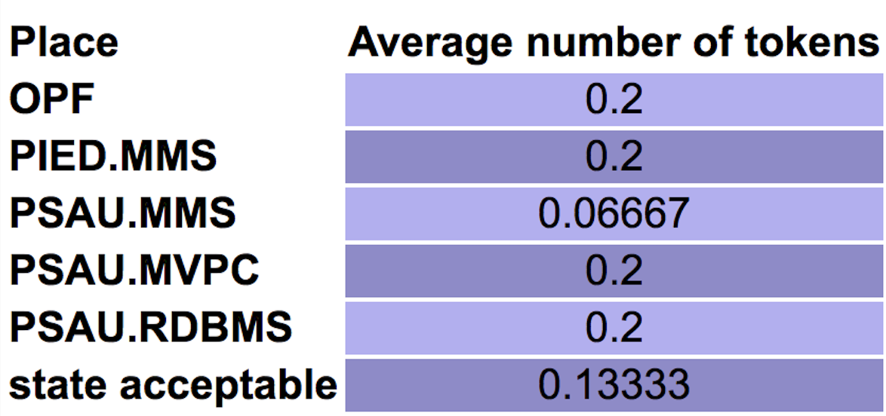

a)MVPC

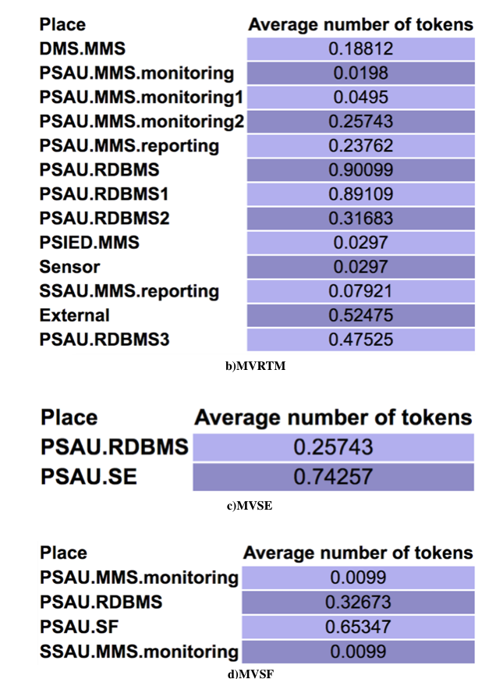

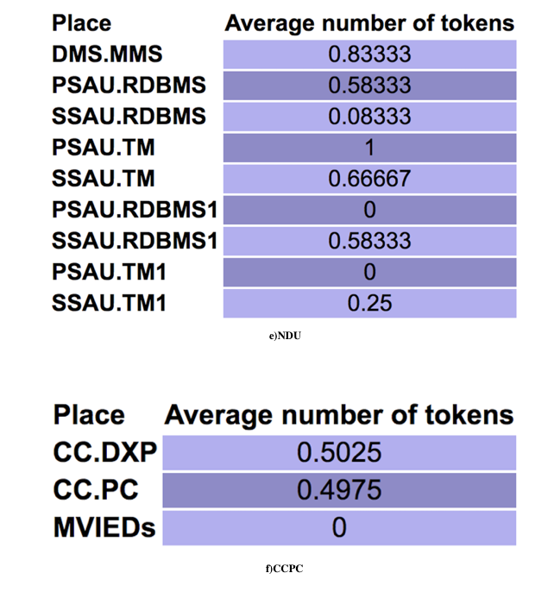

Fig.22 PIPE simulation results



Table 3: Average tokens sorted descending

As can be clearly seen from the above tables, PSAU.RDBMS has the greatest impact in function level and PSAU is the most important component for survivability with a rough judgment. Therefore, we will pay more attention to PSAU in subsequent dependability analysis in next section. Note that the analysis of other components cannot be ignored.

Aforementioned modeling method focuses on data transfer in different scenarios of different use cases to address entire data chain. It shows the interdependencies between different functions step by step. The advantage is that each transition indicates a specific event, easy to understand and find the details. The disadvantage is also obvious: PN is too complicated to carry out further calculations. So in next section we will try to use logical chain to abstract PN.

* 1. Theoretical basis behind qualitative analysis results

For increasing grid resource actors, there are different control approaches:

1. Centralized automation (CA) architecture:

- Coordination takes place at the control center level, the distribution management system (DMS)

- Centralized high data risk, time consuming execution

2.IDE4L automation distribution architecture：

-Allocating the intelligence at each voltage level, PSAUs are responsible for the MV network and SSAUs address the need related to LV network

-Reducing the DMS computational and communication burden, while maintaining the possibility to coordinate the automation in a hierarchical way

-A proper coordination among the SAUs and with the DMS guarantees effective monitoring and control functionalities within shorter time frames than CA approaches and with higher efficiency than the fully distributed architectures.

1. Modeling of IDE4L for dependability evaluation using STPN
   1. IDE4L automation frame

This section attempts to abstract the main failure modes from complex use case scenarios, and then be able to model the failure chain using STPN. Stochastic Time Petri net is a type of timed Petri nets where transitions may occur (“fire”) after random time, including two types: timed transitions (drawn as boxes) and immediate transitions (drawn as bars). Generally transition delays are assumed to be exponentially distributed which ensure the convenient transformation from STPN to an equivalent Continuous-Time Markov Chain (CTMC). CTMC is an important prerequisite for following easy mathematical analysis. Using STPN model, we can evaluate the overall dependability by two metrics —— reliability and availability. Detailed probabilities derivation will be figured out in section 7 in both transient and steady state situation.



Fig.23. The system model of smart grid [10]

The purpose of this section is a perceptual knowledge of IDE4L architecture at the logical level (component layer). Through the combination of general model of the smart grid (Fig.23) and the IDE4L system (Fig.3), we abstract four physical components namely Sensor, IED, PSAU and DMS (SCADA) for indication. Then we separate each component into two operation states: normal operating mode (on) and failing down mode (down). Then exist 8 places corresponding to different states in STPN: Sensor_on, Sensor_down, IED_on, IED_down, PSAU_on, PSAU_down, DMS_on， DMS_down. Initially, each device is in the normal operating mode, which is denoted by one token in Sensor_on, IED_on, PSAU_on or DMS_on. But after suffering from diverse possible failure events (transitions firing), normal operating modes will transfer to failing down mode denoted by the place Sensor_down, IED_down, PSAU_down, and DMS_down.

A failure event can influence the non-adjacent elements located on the information chain (in this section modeled with STPN) in a cross level, and this interaction is the difficulty and significance of following modeling. It must be noted that we will ignore the details of the various failure events (actions), only concern about the results of these events, which led to failures. This makes it unnecessary for us to understand in detail the specific mechanism of each transition.



Fig.24. Frame in IDE4L [5]

* 1. Mathematical basis

1. Reliability

Reliability is used to evaluate the capability to continuously provide services without failures. In detail, it can be defined as the probability that the control center networks work correctly during the period [0,t], R(t) = Pr{X > t}, where X is the continuous random variable of correct operation time for control center networks:

Transient: 

Steady-state: 

2. Availability

Availability describes the toughness of correct services for some critical components:

Transient: 

Steady-state: 

Calculation method of reliability and availability in both steady state and transient aspects involves two steps:

1.the analysis of the equivalent continuous time Markov chain

2.the computation of reliability and availability.

As the theory in [12] has proved that k-bounded SPNs are isomorphic to CTMC (Continuous Time Markov Chain) due to the memoryless property of the exponentially distributed service time. It is easy to infer an association between SPNs’ markings with the CTMC’s states to achieve the isomorphism property [13].

Thus, there are two equivalent methods to compute the steady-state probability of CTMC:

$\left\{\begin{aligned}\prod{ × Q =0} \\ \sum_{i=0}^{n}{π_{i}}=1\end{aligned}\right.$ (1)

For further calculations, we first define the variables in the formula:

1.The infinitesimal generator Q=[qij], where qij(i $≠$ j) indicates the transition rates from states Mi to Mj ,Mi to Mj, qij = 0 if Mj can not transform from Mi；

2. $π_{i }$ is steady-state probability which can be obtained from these linear equations.

This method suitable for calculations on clusters:

$\left\{\begin{aligned}\left(\sum_{j}{λ_{j}}\right)π_{i}=\left(\sum_{k}{λ_{k}}\right)π_{k} \\ \sum_{i}{π_{i}}=1\end{aligned}\right.$ (2)

Similar to method 1, we first define the variables in the formula:

1. is the Firing Rate of Transitions;

2. is steady-state probability, which can be obtained from these linear equations.

Transient probability in above two methods can be derived by：

$\frac{dπ(t)}{dt}=π(t)Q$ (3)

$π\left(t\right)=\left[π_{1}\left(t\right),π_{2}\left(t\right),…,π_{n}(t)\right]$ (4)

Specific mathematical calculations are very complex; fortunately we have software that can independently complete the calculation. With ORIS's own performance analysis tool, we can quickly obtain transient and steady state analysis results both in data and graph.

The GSPN analysis is an analysis of the probabilities of being in a certain state at a certain moment in time, given that the process started from another given state. This analysis generates a matrix, with time as the first dimension and the possible arrival states, starting from the initial marking, as second dimension. Generalized Stochastic Petri Nets (GSPN) is a kind of Petri net, whose timed transitions have exponential distributions, and immediate transitions have 0-Dirac distributions. Obviously the STPNs in this section satisfy both conditions.

Combined with the mathematical theory in 6.2, the result of GSPN analysis is $π_{i}$ (t). With $π_{i}$ (t) and equation (3) we can compute the reliability and availability of each component using formulas (5) - (8):

 (5) ———— Transient reliability

 (6) ———— Steady state reliability

 (7) ———— Transient availability

 (8) ———— Steady state availability

$a_{i}$: The weight of each transition, for the sake of simplicity, all equals to 1.

In order to facilitate the subsequent comparison, we take the steady states probabilities $π_{i}$ to represent the characteristics of these two metrics and indicate the dependability.

GSPN analysis can be performed on the various architectures modeled in section 6.3 and 6.4, after data processing and induction we can obtain the failure results including the number of failed UCs and the failure probability of each UC in table 4:

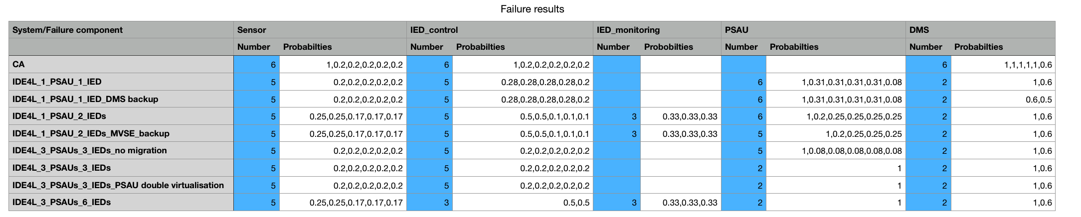

Table 4:Failure results

The number of failed use cases marked by blue shows clear downward trend from CA to simple IDE4L and then to IDE4L with protection approach.

For better comparison, we list detailed failure probability of each use case in table 5:

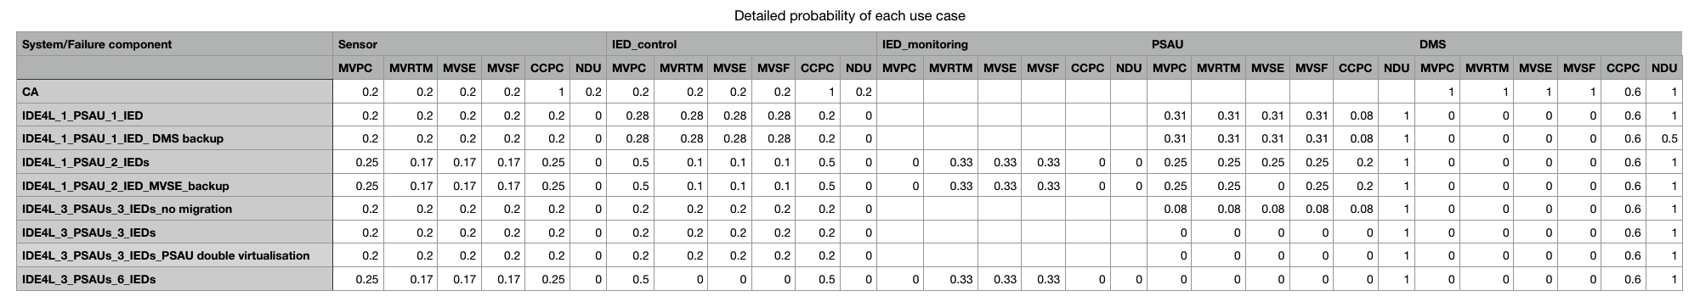

Table 5: Detailed failure probability of each use case

Above is just an intuitive impression of all the data we can achieve from GSPN analysis function; we will present detailed comparative analysis corresponding to the specific model later.

For each Sensor, IED, PSAU and DMS, there are three common ways for destroying the components: communication link failure, device physically breakdown and data corruption, which are separately denoted by transitions TCLF, TDC and TDPB. PSAU has a particular cause of failure：database hacked denoted by TDH.When the component is compromised, meaning that there is a token moves from input places PSensor_on , PIED_on, PPSAU_on or PDMS_on to PSensor_down , PIED_down, PPSAU_down or PDMS_down. The firing rates of TCLF, TDC , TDPB and TDH are 1, 2, 3, 4 noted in table 6：



Table 6:The Firing Rates of Transitions [10]

* 1. Centralized automation vs. IDE4L

For simplicity, in this section, we first assume a normal substation network equipped with only one sensor, three IEDs, three PSAUs and one DMS server, the most common configuration in the current grid structure, to demonstrate the dependability evaluation and performance comparison procedures, then discuss some protection approaches for core component or single use case to improve the distribution automation system dependability.

We first set up the frame (Fig.25) between Sensor, IED, PSAU and DMS in IDE4L architecture (circled by red boxes in Fig.24):

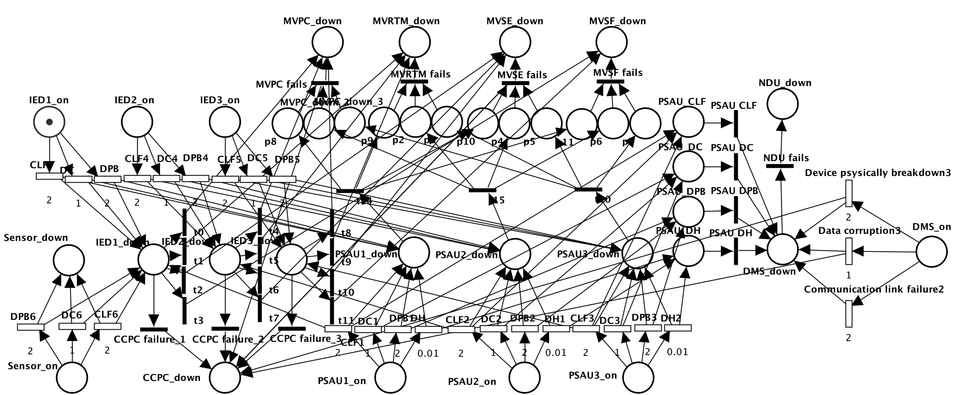

Fig.25 IDE4L architecture STPN

In order to achieve the comparison, we also model the centralized architecture using STPN (Fig.26):

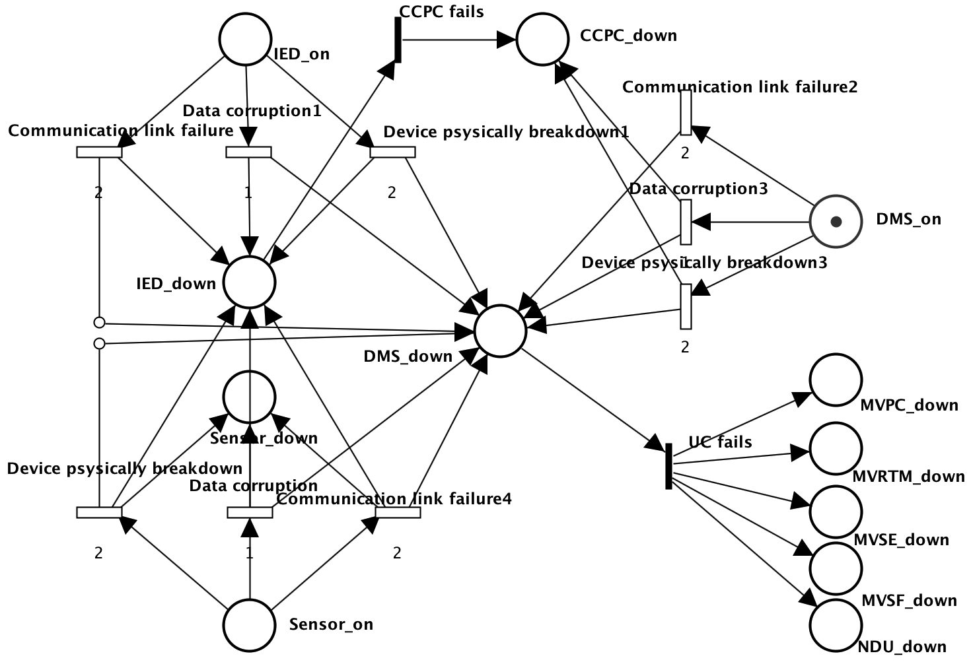

Fig.26 Centralized automation (CA) architecture STPN

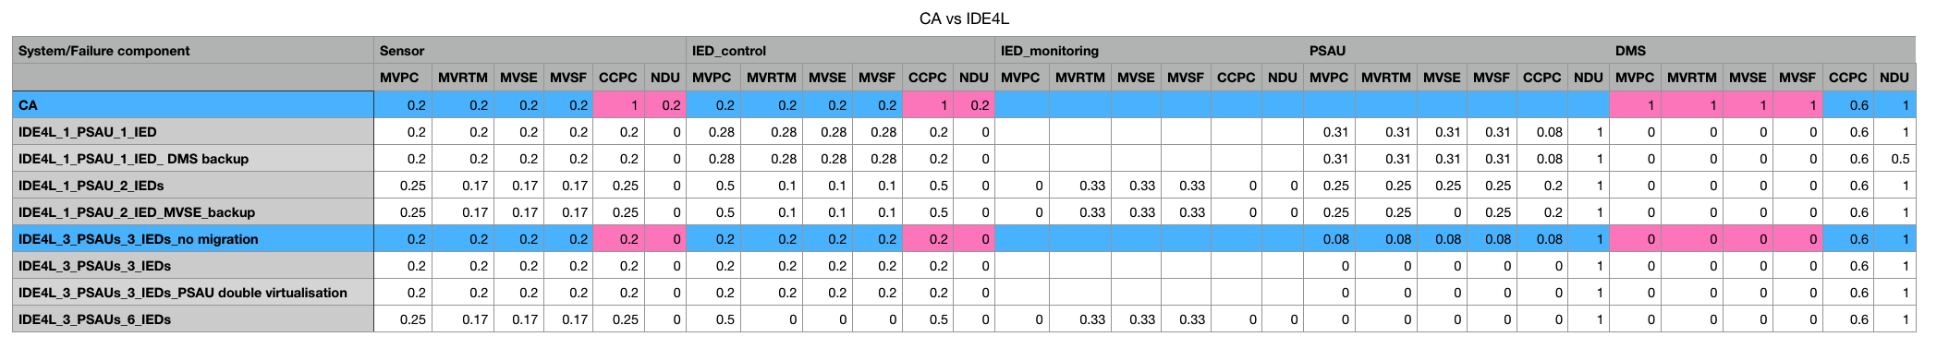

Table 7: CA vs. IDE4L

In table 7, horizontal list different UC failure in different component failure scenarios, vertical list different system architectures. Intersection cells contain the UC eventually failing probability as a particular component fails in a certain system structure.The cell with red background is the different data between compared architectures; we can clearly find IDE4L significantly decreases the failure probability of most use cases. When a sensor or IED fails, the failure probability of NDU decrease from 0.2 to 0 while CCPC from 1 to 0.2;when DMS fails, failure probability of MVPC, MVSE, MVRTM, MVSF decrease from 1 to 0.Other increasing probabilities are instant, which can be avoided by the approaches mentioned later.

* 1. Approaches to improve distribution automation system dependability

According to the conclusion of section 5.7, PSAU is the core component of the architecture, so we first take the protection of other components, DMS, IED into consideration, then comes the protection of a single use case, at last consider the PSAU protection measures, including the function and database backup.

* + 1. DMS backup-strategy

One Sensor, one IED, one PSAU and one DMS with Backup strategy:

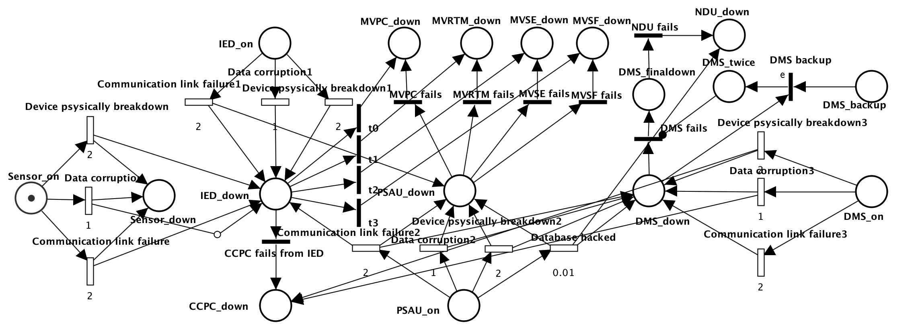

Fig.27 DMS backup-strategy

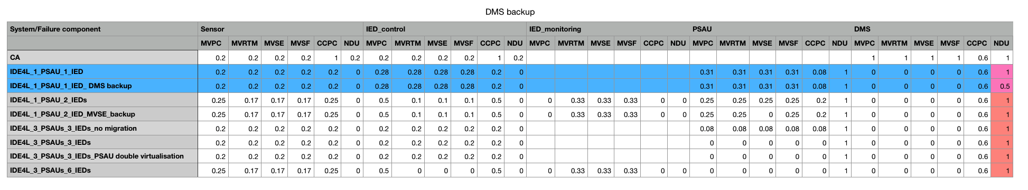

Table 8: DMS backup-strategy

From Table 8, DMS backup-strategy is targeted for NDU in case of DMS failure (from 1 to 0.5). It is worth noting that in all the protective measures, only it can reduce the risk of NDU failure.

* + 1. Bad/Missing data detection/correction

One Sensor, two separated functional IEDs, one PSAU and one DMS with Bad/Missing data detection/correction：

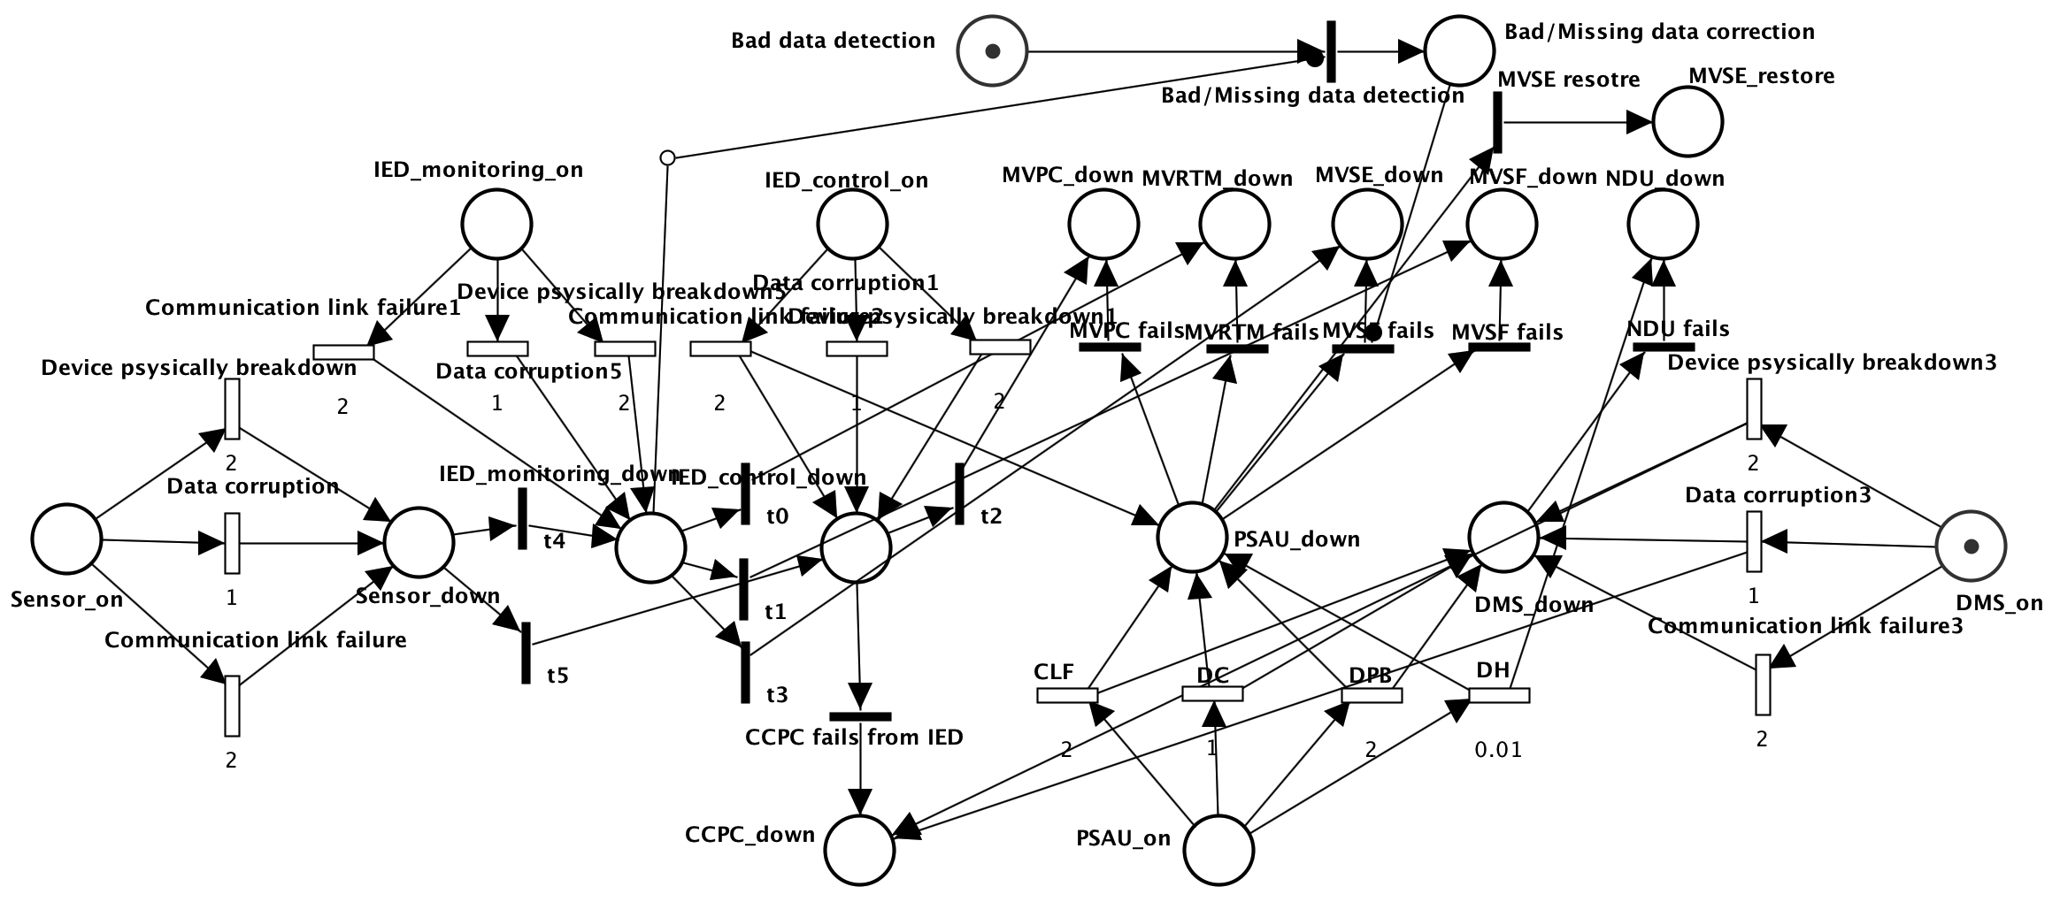

Fig.28 Bad/Missing data detection/correction

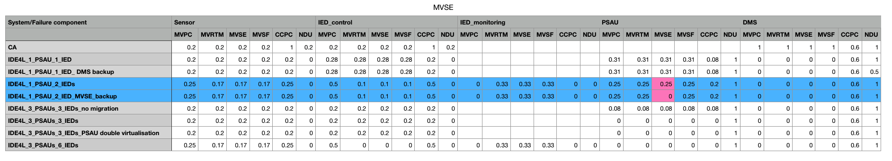

Table 9: Bad/Missing data detection/correction

From Table 9, Bad/Missing data detection/correction decreases the failure probability of MVSE in case of PSAU failure from 0.25 to 0.

* + 1. Separate single IED into control and monitoring IEDs

One Sensor, two separated functional IEDs, one PSAU and one DMS:

Each single IED will be separated into two functional IEDs i.e. IED_control and IED_monitoring, which response for different funtions.

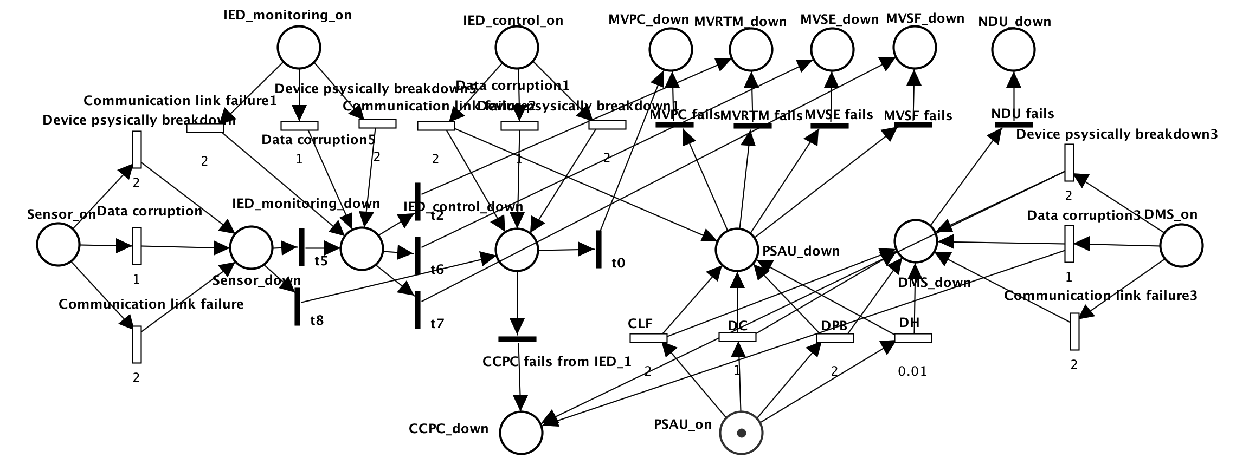

Fig.29 Separate single IED into control and monitoring IEDs

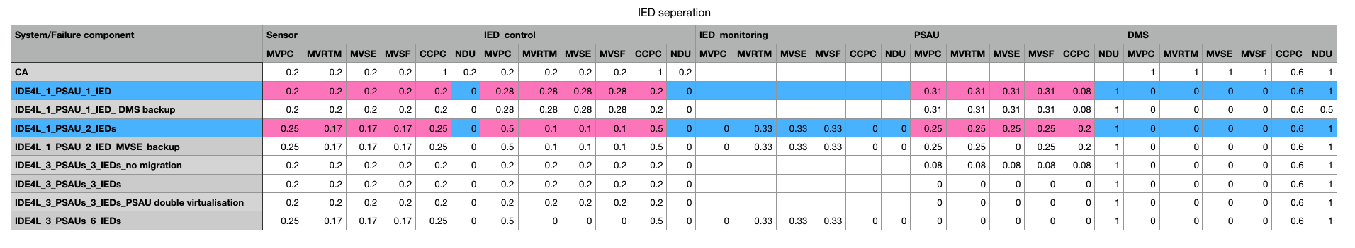

Table 10: IED separation

From Table 10, the MVRTM, MVSE and MVSF in case of sensor failure slightly decreases from 0.2 to 0.17, while MVSE, MVSF and MVRTM in case of IED_control failure decreases from 0.28 to 0.1,in case of DMS failure decreases from 0.31 to 0.25.The reason is that MVSE, MVSF and MVRTM is only affected by monitoring IED, and MVPC and CCPC only by control IED. When one type of IED (e.g. IED_control) fails, it does not affect the data collected and processed by another type of IED (e.g. IED_monitoring), thereby distracting the risk.

* + 1. PSAU migration

One Sensor, one IED, three PSAUs and one DMS:

When one PSAU fails (e.g. PSAU1), all the functions and data of this PSAU will be migrated to another one (e.g. PSAU2 or PSAU3). This means only when all PSAUs falling down lead to the final functional breakdown. Here exist only one IED which responsibles for 3 PSAUs, this situation does not exist in IDE4L, just as a contrast.

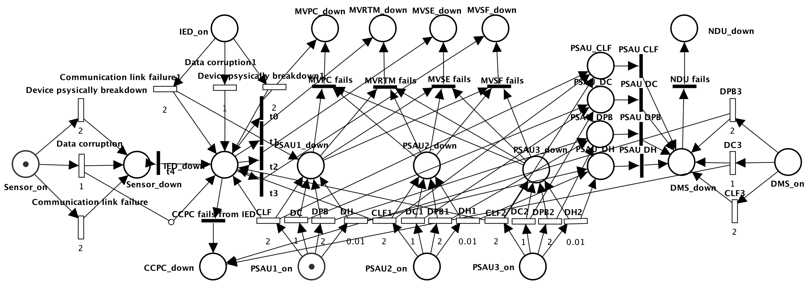

Fig.30 PSAU migration

Or One Sensor, three IEDs, three PSAUs and one DMS (this situation is more common):

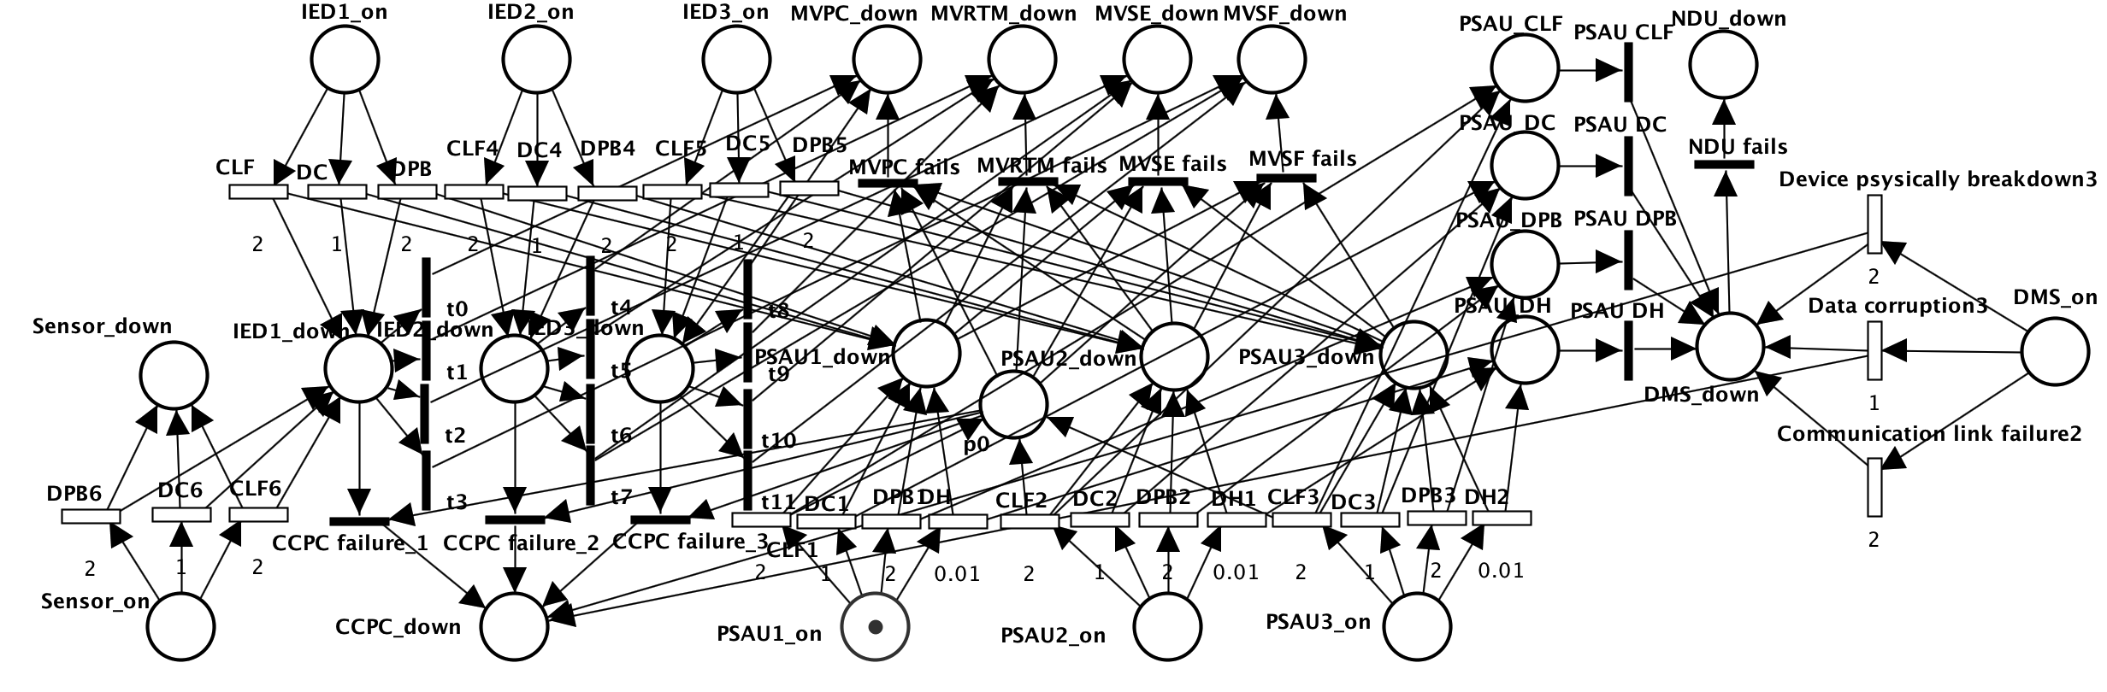

Fig.31 PSAU migration

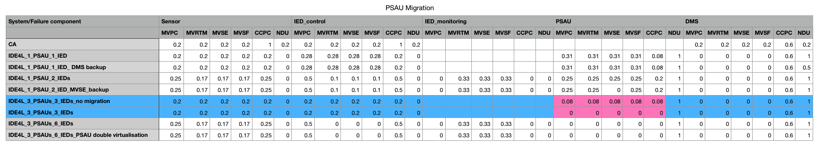

Table 11: PSAU migration

From Table 11, PSAU migration can powerfully eliminate the risks of PSAU failures.

For a better comparison, we combine two approaches together (PSAU migration and IED seperation that will be mentioned later):

One Sensor, six separated functional IEDs, three PSAUs and one DMS:

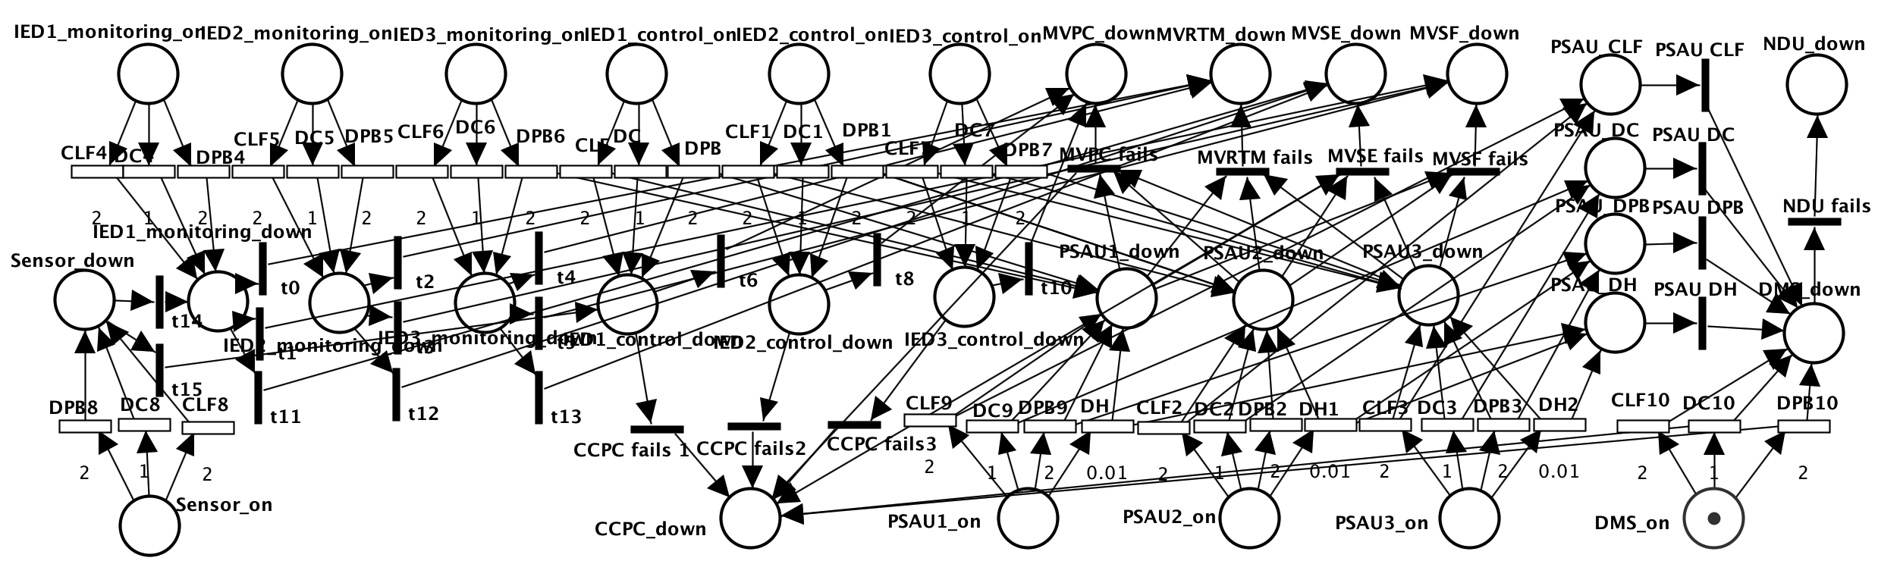

Fig.32 Separate single IED into control and monitoring IEDs while PSAU migration

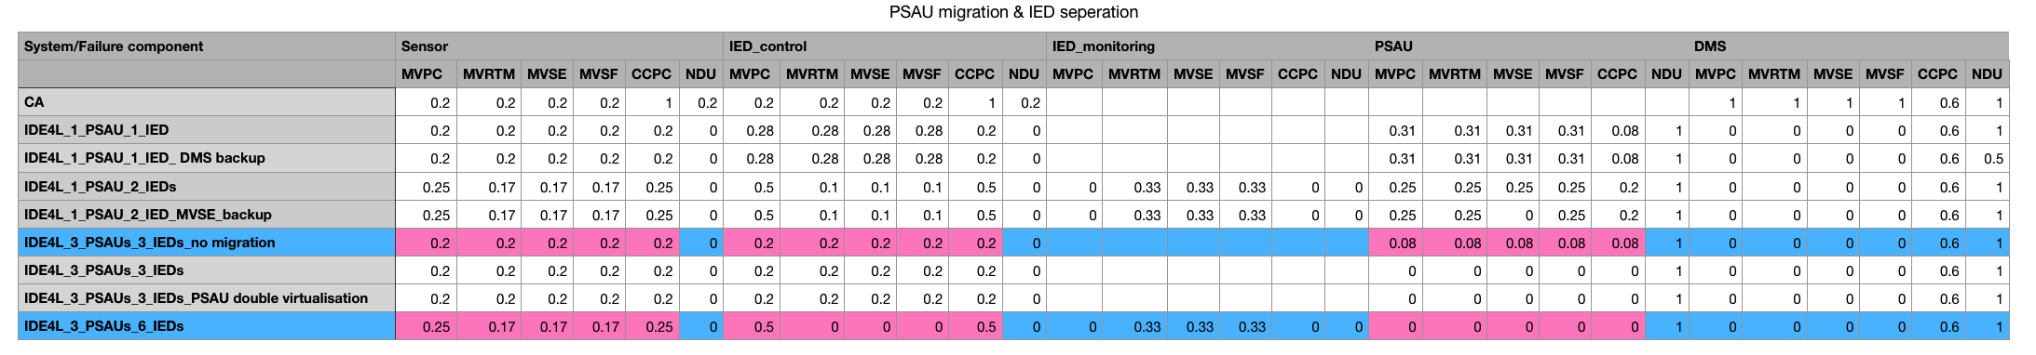

Table 12: Separate single IED into control and monitoring IEDs while PSAU migration

From Table 12, IED separation and PSAU migration can be complementary for most UCs in case of Sensor, IED and PSAU failure. This shows that different protection measures can be achieved at the same time.

* + 1. PSAU double virtualization

IDE4L automation distribution architecture with PSAU-double virtualization:

One Sensor, six IEDs, three PSAUs and one DMS.

Double virtualization: The functional and data layers, which will contain functional and data entities, will be logically separated, i.e. the decentralised distribution automation functions and the database used to store the measurement values based on which these automation functions are applied, e.g. Smart Meters (SM) or Phasor Measurement Units (PMU) will be virtually located in different zones. The realization of PSAU double virtualization concept is based on cloud computing platform. It is possible to migrate virtual control functions between isolated locations, which are logically and/or physically separated.

When a system failure occurs, the virtual relocation of the virtualization control function is triggered by the virtual machine, allowing functions or database of the PSAU to be restored. In the logical expression, these two different scenes have the same representation, we can represent that PSAU has a virtual backup, denoted by place PSAU_backup. When the PSAU fails, the backup is fired, playing a protective role.

To some extent, PSAU double virtualization can be considered as another version of the PSAU migration, in which the migration occurs between Virtual Primary Substation Automation Units (vPSAU)

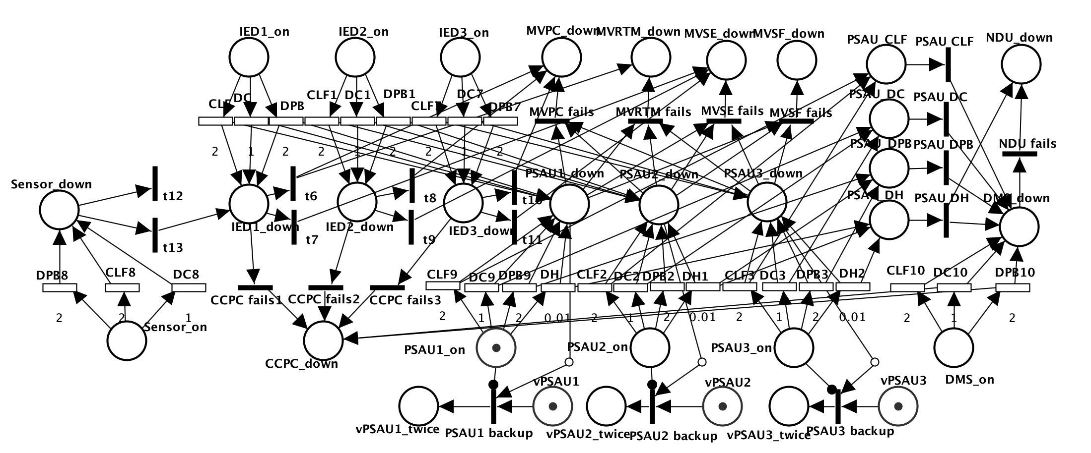

Fig.33 PSAU double virtualization with function backup or database backup

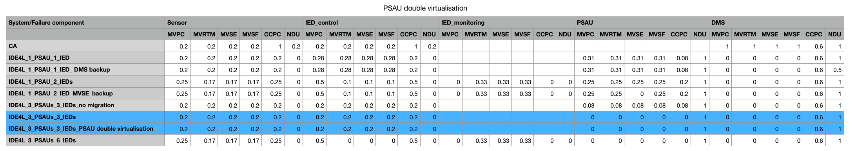

Table 13: PSAU double virtualization

From Table 13, PSAU double virtualization and PSAU migration have the same affect.

* 1. Analysis of the results

As the transient period is too short (less than 1s), we should take the steady state metric as key performance indicator (KPI). Corresponding to equation (6), steady state reliability cannot be used as an indicator as it remains 0.Using equation (8), we can obtain the steady state availability from the GSPN analysis results shown in 6.4：

In the schematic diagrams in this section (Figure 34-39), each graph consists of 3-5 small graphs: a)in case of sensor failure; b)in case of IED_control failure; c)in case of PSAU failure; d)in case of DMS failure; e)in case of IED_monitoring failure, representing the steady state availability (y-axis) of the six use cases (x-axis) in case of different component failure:

1. Compared with centralized automation, IDE4L improve the availability of most use cases. Availability of a few UCs decrease, which can be avoided through following protection approaches (NDU is directly controlled by DMS).

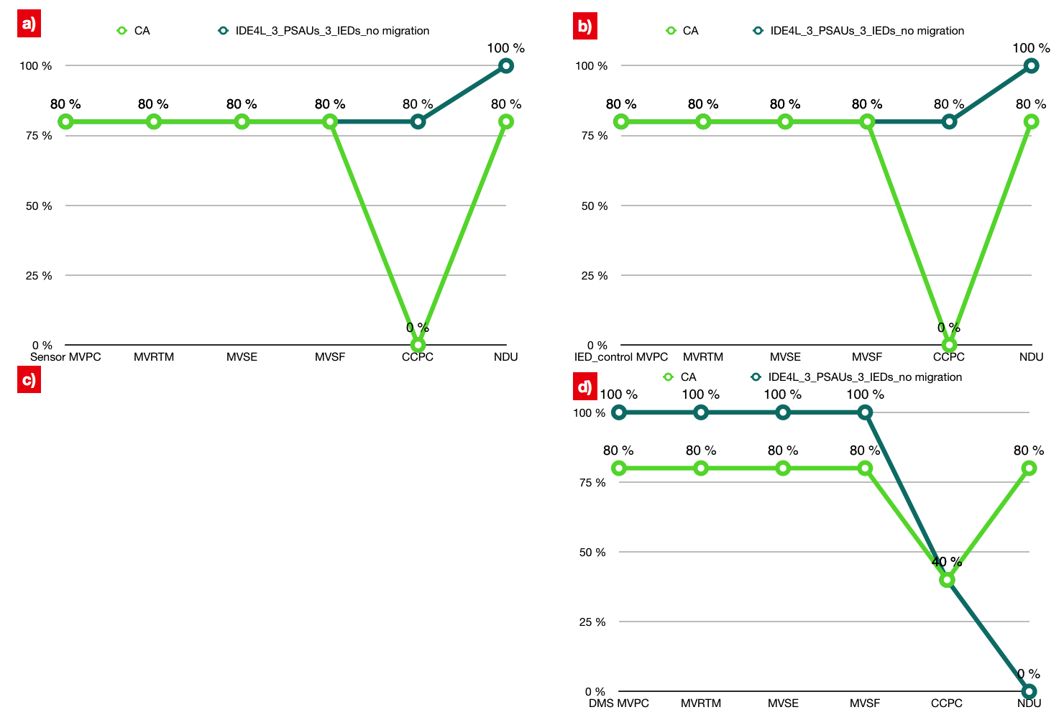

Fig.34: CA vs. IDE4L

1. DMS backup strategy is most targeted, for the protection of DMS, especially irreplaceable for NDU (from 0% to 50%).

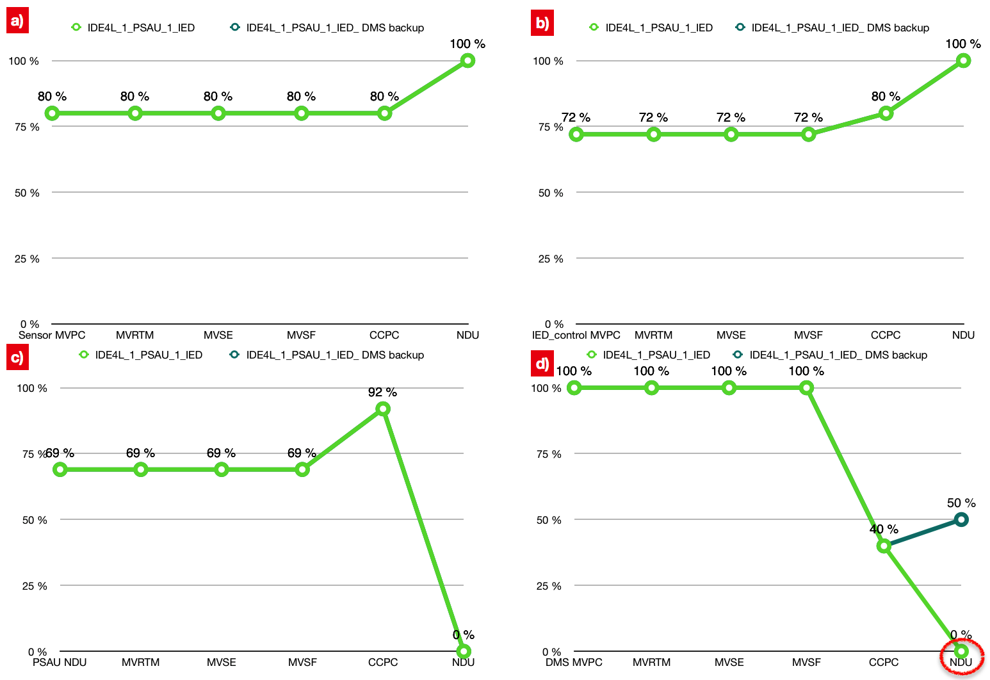

Fig.35: DMS backup strategy

1. Bad/Missing data detection/correction mainly protects MVSE (25%) in case of PSAU failure.

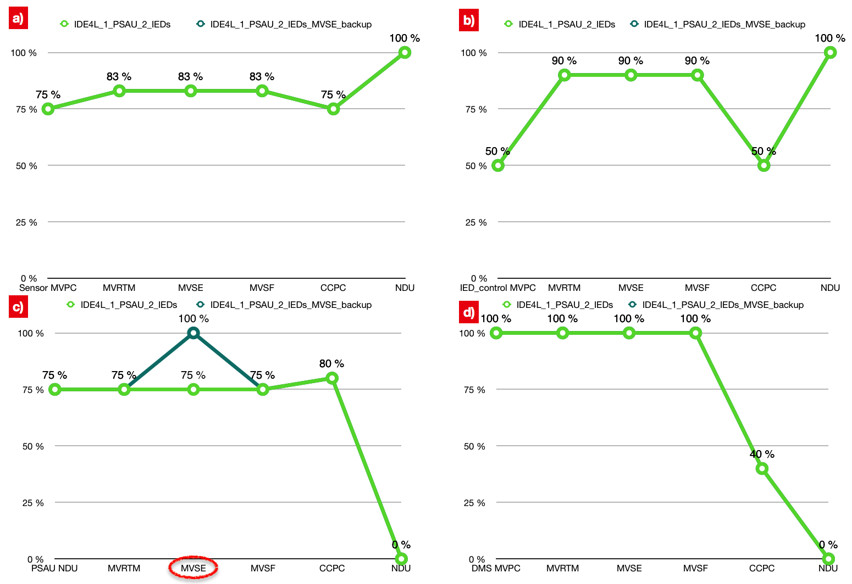

Fig.36: Bad/Missing data detection/correction

1. The functional separation on IED can improve the availability of most use cases in case of Sensor, IED and PSAU failure.

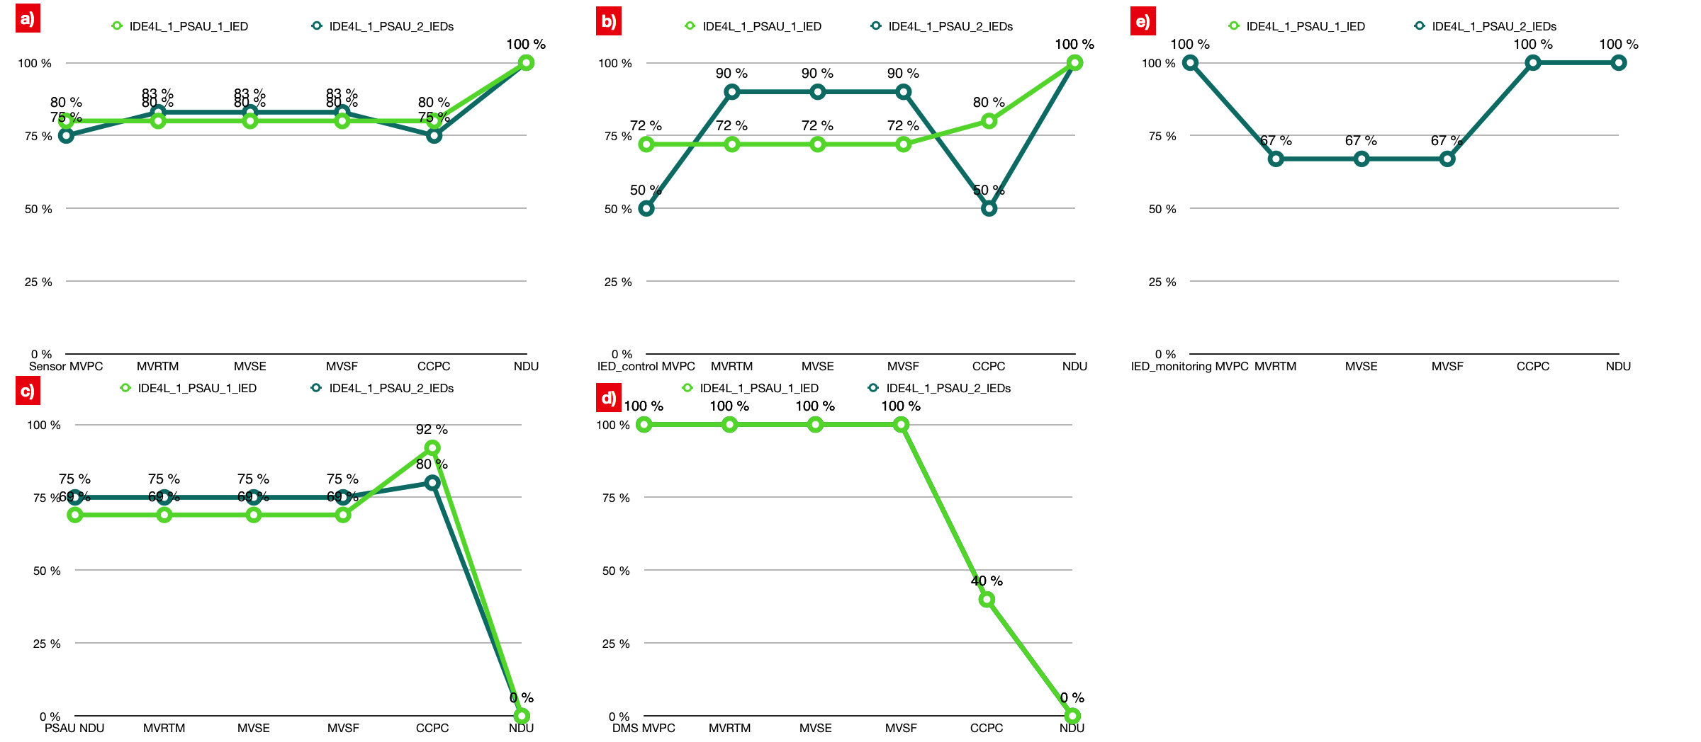

Fig.37:IED Separation

1. PSAU migration has a strong protective effect for use cases in case of PSAU failure.

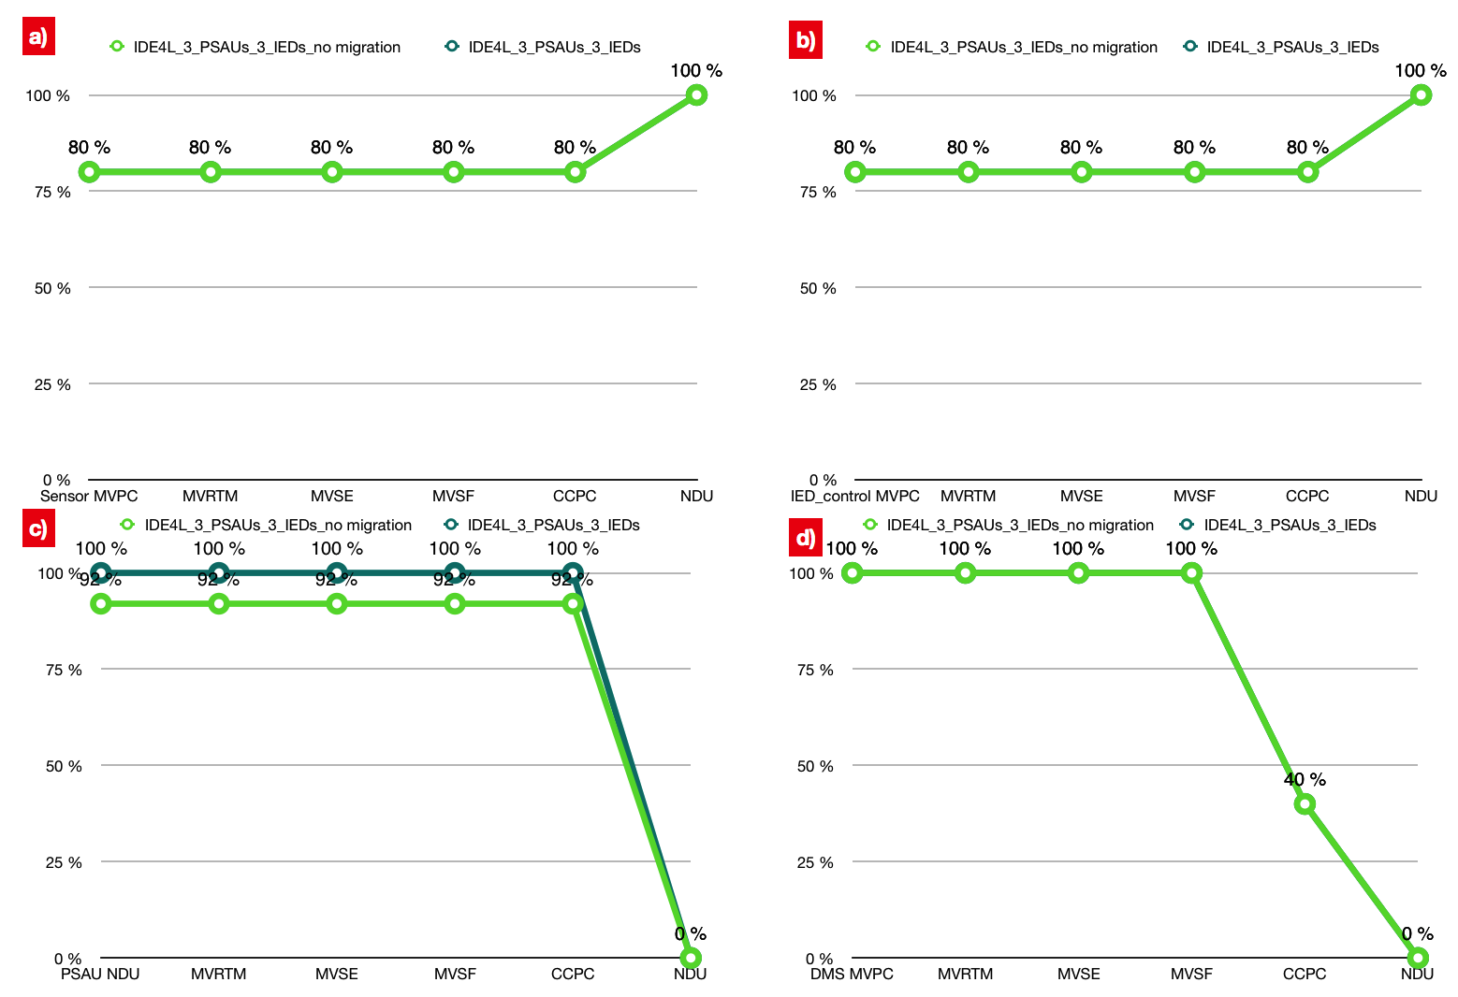

Fig.38: PSAU migration

1. PSAU double virtualization and PSAU migration have the same affect. But when one part of double virtualization(database or function) fails, it will result as the same as no migration situation.

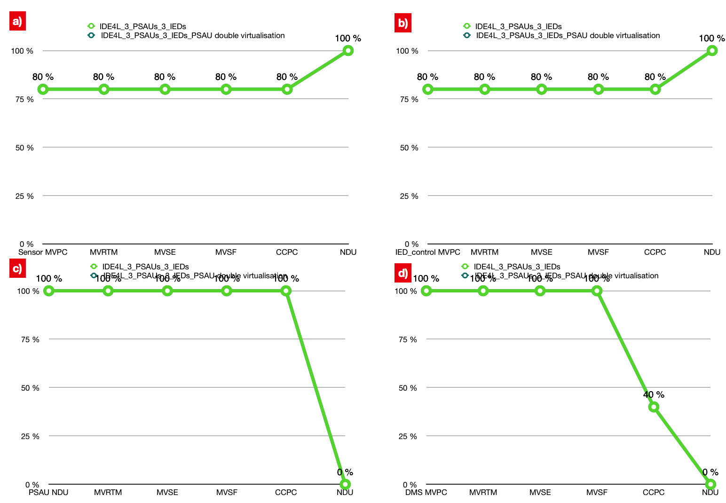

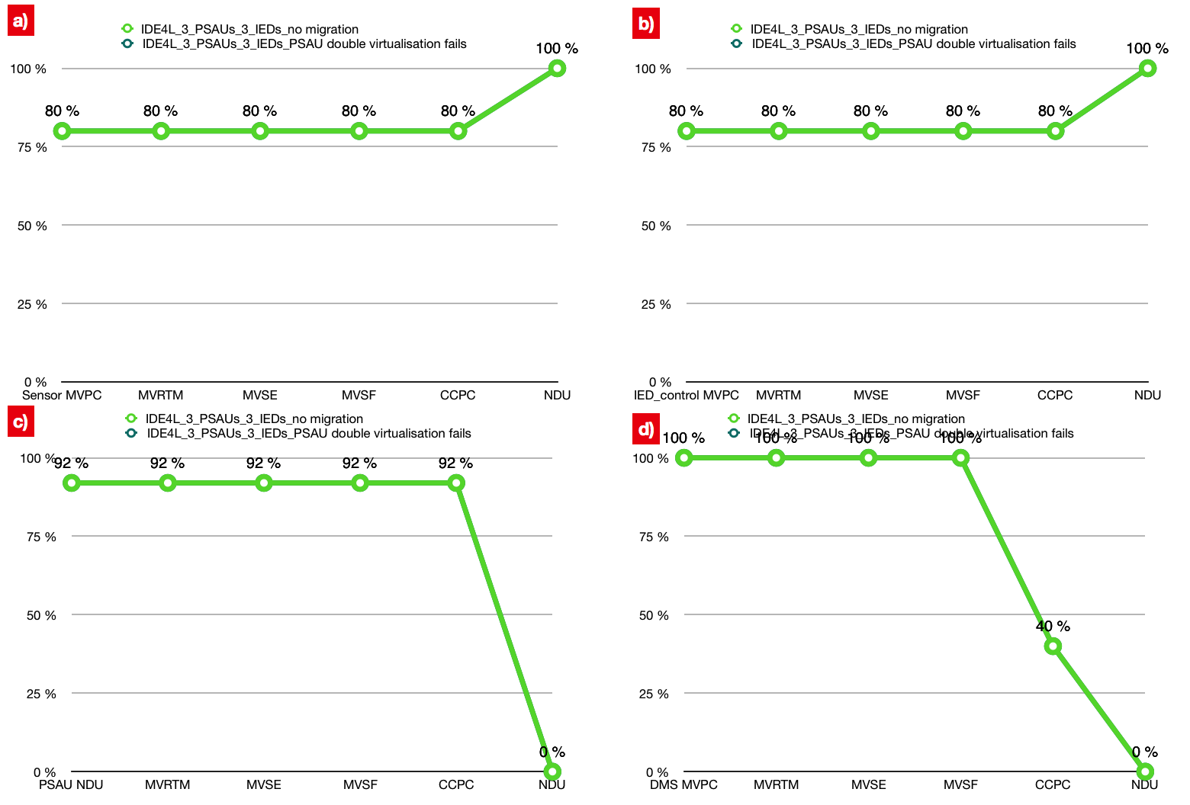

Fig.39: PSAU double virtualization

1. Conclusions

This thesis is a feasibility study on using Petri Net theory for modeling and analyzing the distribution automation system, taking petri net as the toolkit, IDE4L system as the research objective, completing an investigation on the modeling of the distribution automation system. The main idea of present thesis is to employ different types of Petri Nets (SCPN, STPN) with different tools (PIPE, ORIS) in different layers (function layer, component layer) for performance analysis (survivability, dependability) of different distribution automation systems (Centralized Automation vs. IDE4L) with different protection approaches in Medium Voltage level (PSAU).

Through logical reasoning and mathematical derivation can we first find the most important and most vulnerable component. Then the feasibility and correctness of the proposed method are illustrated by a detailed study of the 6 major use cases in MV level. The reliability and availability analysis of several different architectures verify the advantages and necessity of the IDE4L system. In order to compare the different characteristics of various protection measures currently allocated to the distribution automation system, the means of DMS backup strategy, Bad/Missing data detection/correction, PSAU double virtualization, PSAU migration and IED separation, are modeled in present thesis. Through the equivalent conversion theory of STPN and CTMC, the steady state availability is obtained as the KPI.

The future work can focus on seeking better protection methods for the core components as well as more detailed petri net modeling, such as communication link actually includes switching, sending, buffering, receiving and other steps. This thesis only explore the system resilience of single component failure, we can go further to its ability to continue functioning even there has a failure of more components. To simplify the large system petri net and avoid the state space explosion problem that may occur in the calculation process, an optimization solution for calculation is also a hot point.

1. Bibliography

[1] Riccobono, Antonino, et al. "Systematic method for the development of future active distribution network automation architectures." *PowerTech, 2015 IEEE Eindhoven*. IEEE, 2015.

[2] Angioni, Andrea, et al. "Design and Implementation of a Substation Automation Unit." *IEEE Transactions on Power Delivery* 32.2 (2017): 1133-1142.

[3] http://www.acs.eonerc.rwth-aachen.de/cms/E-ON-ERCACS/Forschung/Forschungsprojekte/Gruppe-Power-System-Automation/~fbew/IDE4L-Ideales-Stromnetz-fuer-Alle/lidx/1/

[4] Repo, Sami, et al. "The IDE4L Project: Defining, Designing, and Demonstrating the Ideal Grid for All." *IEEE Power and Energy Magazine* 15.3 (2017): 41-51.

[5] http://ide4l.eu/results/ Deliverable 3.1: Distribution Automation Concept

[6] Murata, Tadao. "Petri nets: Properties, analysis and applications." *Proceedings of the IEEE* 77.4 (1989): 541-580.

[7]Bonet, Pere, et al. "PIPE v2. 5: A Petri net tool for performance modelling." *Proc. 23rd Latin American Conference on Informatics (CLEI 2007)*. 2007.

[8] http://www2.tu-ilmenau.de/sse_file/timenet/

[9] http://www.oris-tool.org/

[10] Zeng, Rongfei, et al. "Dependability analysis of control center networks in smart grid using stochastic petri nets." *IEEE Transactions on Parallel and Distributed Systems* 23.9 (2012): 1721-1730.

[11] <http://ide4l.eu/results/> Detailed use cases

[12] K. Molly, “On the Integration of Delay and Throughput Measures in Distributed Processing Models,” PhD dissertation, Univ. of Califormia, 1981.

[13] R. Zeng, Y. Jiang, C. Lin, X. Chu, and F. Liu, “Performance Analysis of Data Management in Sensor Data Storage via Stochasitc Petri Nets,” Proc. IEEE Global Telecomm. Conf. (Globe- com), pp. 1-5, 2010.

1. Appendix
   1. PIPE installation and functions
      1. PIPE installation

Now PIPE 5, the Platform Independent Petri Net Editor version 5 is the newest version, which can be found in <https://github.com/sarahtattersall/PIPE>. In this website, you can obtain useful information on how to use PIPE and what's changed with this version.

The software was originally released at SourceForge（http://pipe2.sourceforge.net/about.html）from PIPE2 to PIPEv4 and then migrated to GitHub - as GitHub is friendly for social coding.

PIPE 5 is currently in beta stage due to an entire re-write of the back end and so is missing most of the analysis modules. So in this thesis we choose Version 4.2.1 in folder PIPEv4 for creating, simulating and analyzing Petri nets.

* + 1. Petri Nets creating

A blank canvas is automatically created as PIPE first opens. Petri net can be drawn on that. All the basic actions for creating and modifying Petri nets can be found using the task bar along the top of the application as well as the drop down menus at the top. A list of Petri net analysis modules can be found to the left of the canvas.

Note on a Mac all shortcuts involving Ctrl should replaced with the cmd option below.

Following we will use MVPC infection 5.1 as an example to demonstrate the procedure of Petri Net creating.

Create a new Petri net 

Create a new Petri net by pressing the new icon, by pressing Ctrl-N, or choosing the new Petri net option from the File menu. A blank canvas will appear where you may create your Petri net using the other actions detailed below. Your new Petri net will be given a default unique name until you save it. You can navigate through all open Petri nets by clicking on the desired Petri net's name in the tab bar above the canvas.

Open an already existing file 

To open an existing Petri net, click the open icon or press Ctrl-O. Your opened Petri net will then be loaded into a canvas that takes focus on the screen.

Save an existing Petri net  

To save an existing Petri net click the save icon, use the save menu option or press Ctrl-S. The save-as option is also available from the task bar, menu or by pressing Ctrl-Shift-S. Once saved your Petri net will be renamed in the tab bar to the name just entered for saving.

Close the current tab 

To close the current tab press Ctrl-W or click on the close icon.

Editing a Petri net

A Petri net can be built up by using the appropriate icons along the task bar.

Adding a token 

In order to add a token to the Petri net click on the new token icon or press Ctrl-Shift-T. This will pop up the token editor window in which tokens can be added by giving them a name and a color.

Noting that this function is the reason why we choose PIPE for SCPN modeling.



Fig.40 PIPE-adding a token

The active token can be changed via the token drop down menu.



Fig.41 PIPE- editing a token

Adding and editing a place 

The place component tool is selected by clicking the icon with a round circle. The place will be automatically named for you.

In order to edit place attributes, such as its name and capacity, right click the place and click 'Edit Place'. The place editor window will then pop up where you can enter the new details for the Place.



Fig.42 PIPE-adding a place

The active token can be added to or removed from places by selecting the relevant icons next to the active token menu  . In order to change which token is added, select the token you wish to place from the menu, then click on the place to add tokens. Alternatively adding tokens can be done in the place editor window as seen above.

Adding and editing a Transition  

Similarly a new transition can be added by clicking either the black rectangle which represents an immediate transition, or the unfilled rectangle which represents a timed transition. The transition can then be created anywhere by clicking on the canvas. It is automatically named, just like when adding a place.

Right clicking on a transition and clicking 'Edit Transition' allows you to edit the transitions attributes and swap between a timed or immediate transition.



Fig.43 PIPE- editing a place

A timed transitions rates may either be static or functional.

Adding and editing an Arc  

Click on either the normal arc (pointed arrow head), or the inhibitor arc (round arrow head) icon and then select the components you wish to join.

A normal arc can join either a place to a transition or a transition to a place. An inhibitor arc can only join a place to a transition and will only fire if the place contains no tokens.

When adding an arc clicking on free space within the canvas will add points along the arcs path, shift clicking will create curved points. Pressing Esc whilst creating an arc will cancel its creation.



Fig.44 PIPE- adding an arc

Again the number of tokens an arc requires can either be static or functional. You can edit the arcs weight by right clicking on the arc and selecting 'Edit Weight'. This brings up the weight editor where a weight can be added for each token declared.



Fig.45 PIPE- editing an arc

Adding a Rate Parameter 

Rate parameters are useful because they allow you to create a shared rate for timed transitions. Modifying this rate will effect any transitions that reference this rate. Click on the rate parameter icon along the task bar and enter a name and value for this rate.



Fig.46 PIPE- adding a rate parameter

This rate can now be selected in the transitions editor window.



Fig.47 PIPE- editing a rate parameter

In a similar manner rate parameters can be deleted from the Petri net. Any transitions that make use of this rate parameter will have their rates set to the parameters value at the time of deletion.

Functional Rates

Supporting marking-dependent rates helps create more expressive Petri nets whilst keeping the design simple. Arc weights and transition rates can now be expressed in terms of other components. Functional rates have the following grammar:

program ::= expression;

expression ::= '(' expression ')' |

expression * expression |

expression / expression |

expression + expression |

'ceil(' expression ')' |

'floor(' expression ')' |

capacity |

token_number |

token_color_number |

INT |

DOUBLE;

capacity ::= 'cap(' ID ')';

token_number ::= '#(' ID ')';

token_color_number ::= '#(' ID ',' ID ')';

Where an ID refers to a place name, or in the case of token_color_number a place name followed by a token name.

Examples

Examples of functional weights using the grammar are given in the table below.

**Expression**

**Meaning**

#(P0)

the sum of all tokens in P0

#(P0, Default)

the number of Default tokens in P0

#(P1, Red)*10

the number of red tokens in P1 multiplied by 10

floor(10.5/3)

the floor of 10.5/3 i.e. 3

ceil(cap(P5) * 2.5)

the ceiling of the capacity (max number of tokens allowed) in P5 multiplied by 2.5

#(P0) + #(P2)

the sum of the total number of tokens in P1 and P2

* + 1. Petri net analysis

Animation mode 

You may toggle animation mode for a given Petri net by clicking on the animation mode button. This mode changes the tool bar along the top to contain useful tools for animation. It also displays the animation history on the left hand side of the screen.

Firing a transition  

Enabled transitions are highlighted in red in animation mode and there are three different ways to fire a transition:

1. Clicking on the transition you wish to fire.

2. Clicking on the random transition button (single lightening bolt). This randomly picks a transition based on priorities and type to fire.

3. Clicking on the multiple animate button. This will ask you how many transitions you wish to fire and the time between firing. It will then randomly select the transitions to animate.



Fig.48 PIPE- firing a transition

Stepping backward/forward  

The backward and forward buttons are located next to the random firing buttons on the tool bar. Press these to step forward and backward through the animation history.

Analysis modules

A biggest reason to use PIPE is for the module support, the numerical results in section 5.7 are obtained from GSPN analysis.



Fig.49 PIPE- Analysis modules

* 1. ORIS installation and functions
     1. ORIS installation

ORIS can be downloaded in http://www.oris-tool.org/ , head to the download folder and unzip the ORIS archive you just downloaded.

Then, you can open the folder created and run ORIS by simply running either *run.bat*, if you are on Windows, or *run.sh*, if you are on Linux or Mac. At least Java 8 installed is the prerequisite.

Following we will use CA in section 6.3 as an example to demonstrate the procedure of Petri Net creating in ORIS.

* + 1. Petri Nets creating

New network creation

The very first step is to create a new empty net by clicking the button  from the toolbar. Alternatively, you can click File → New, from the menu, or use the shortcut Ctrl + N.

Adding places

Let's start by adding a new place: to add a new place just click on the  button and then on a random position on the canvas. You can see a new place will spawn, as shown below:



Fig.50 ORIS- adding a place

If we now double click on the place we just created, we can specify its name and the number of tokens in that place in the initial marking. Let's call it *Sensor_on* and give it one token, as shown below:

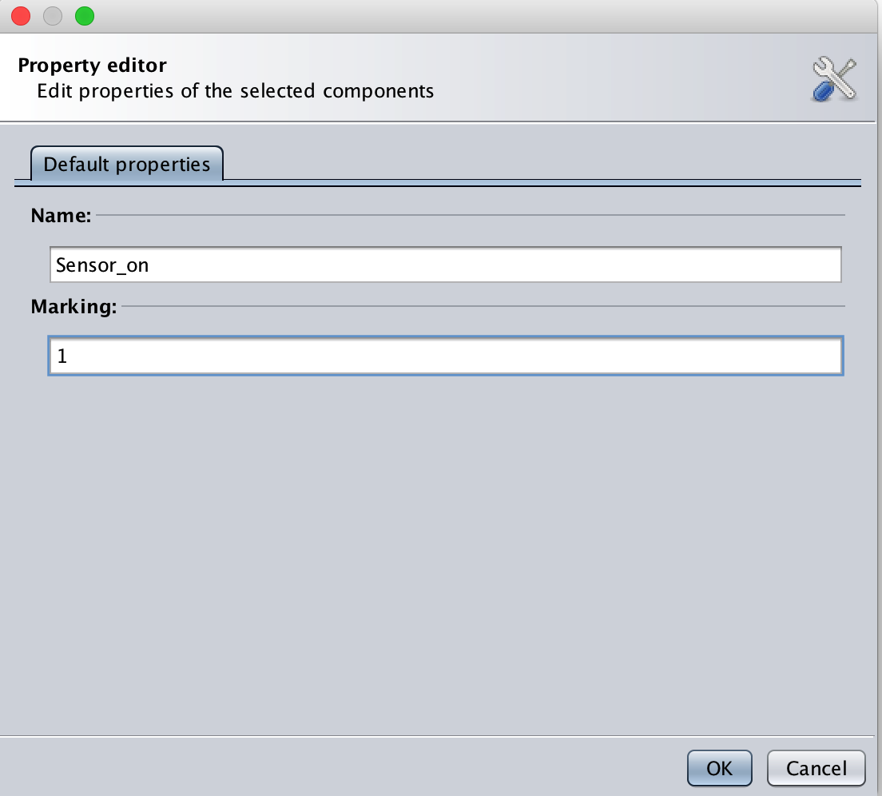

Fig.51 ORIS- editing a place

Now let's click *OK* to make the changes permanent.

**Tip 1:** If you select the  button you'll enter in "selection mode" and be able, for example, to drag the place's name for a better readability. With the same method we've just seen, let's add the other places: Sensor_down, IED_on, IED_down, DMS_on, DMS_down, with zero tokens.

**Tip 2:** When you drag an element, ORIS will show some helpful alignment lines.

Adding transitions

Now that we have all the places we need set, let's add some transition.

Stochastic Time Petri Net (STPN) means the transition may have time delay , we want to add exponential and immediate transition. Let's double click on the newly created transition to customize its parameters as follows:

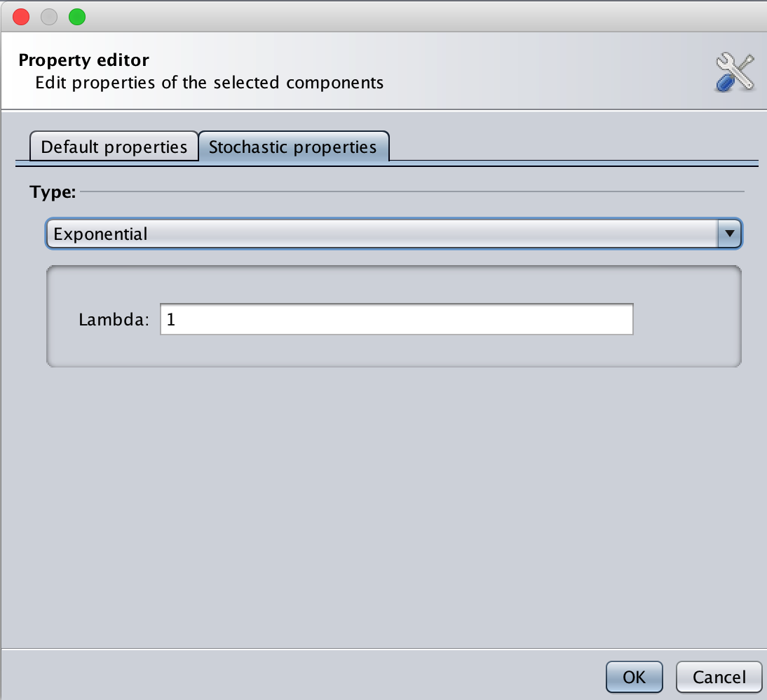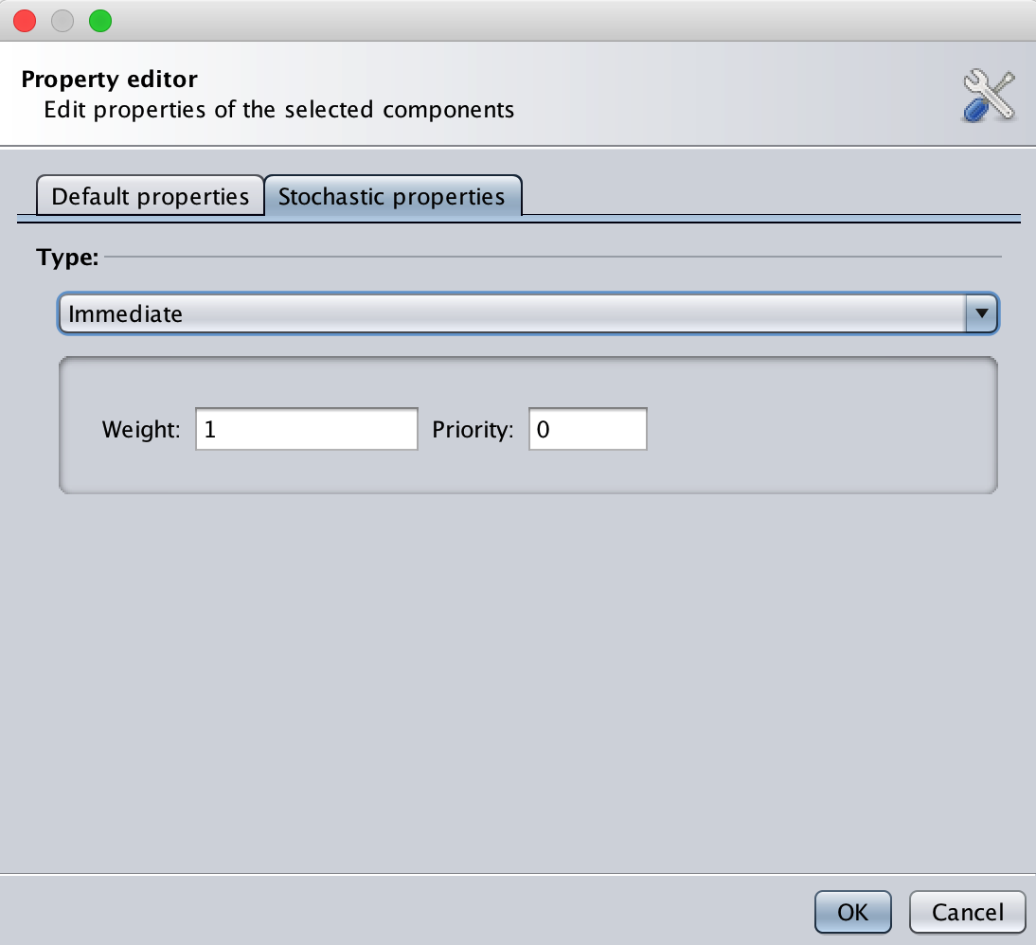

Fig.52 ORIS- editing a transition

Lambda is the firing rate defined in table 6.

Finally, selecting the , we can create an arc between a place and a transition (or vice versa) by dragging the arc from the starting element to the destination element: in this case let's create an arc from *ready* to *send* and another one from *Sensor_on* to *Sensor_down*.

The result should be as follows:

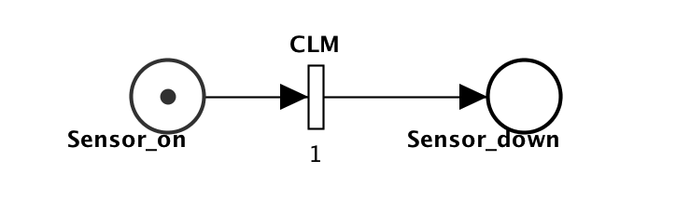

Fig.53 ORIS- edited transition

In section 7 the logical function of STPN is realised though these transition attributes.

If you're wondering what does that little *e* on top of the transition means, it stands for *enabling function*, which has been used in back-up strategy.

Let's add the rest transitions (DC, DPB) now.

**Tip3:** If you double-click on an arc, you can create joint nodes, for a better organization.

If done properly, the final result should be as follows:

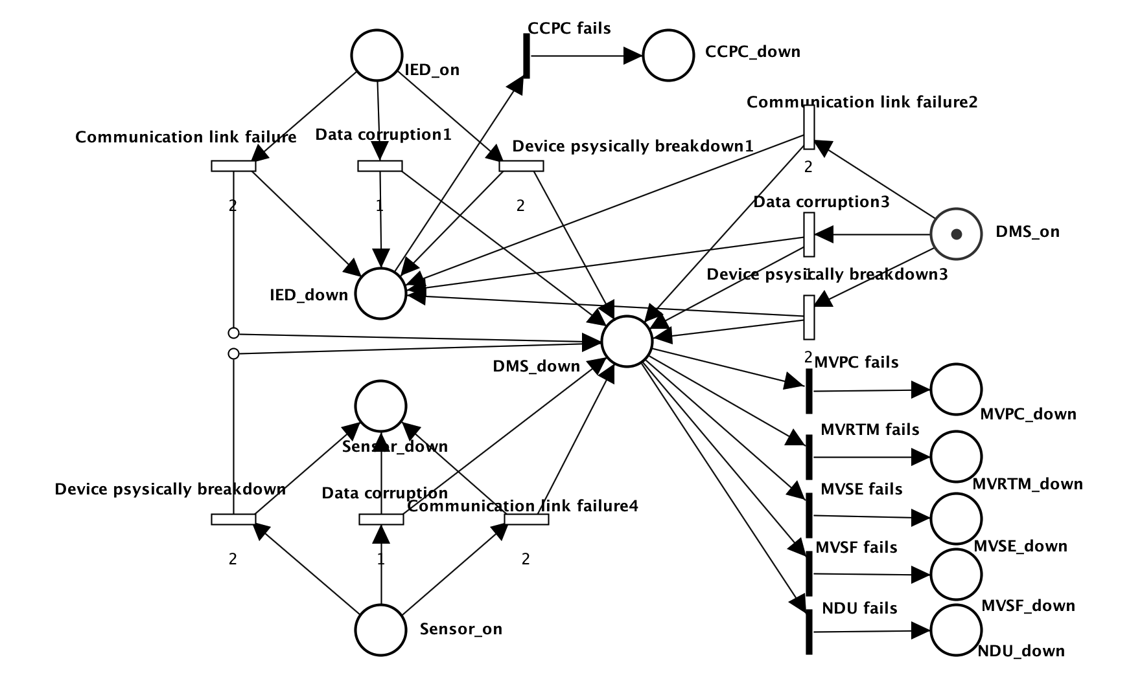

Fig.54 ORIS- an example of Petri net

Saving the PN

The Petri Net is now completed and ready to be used for various analyses.

Remember to save the Petri Net before closing, by clicking the  button, if you want to reuse the net later. This process will generate a file in XPN format that contains the Petri Net description.

* + 1. Petri Nets analysis

Regenerative transient analysis

One of the most useful analyses that can be conducted on a Petri Net is the *regenerative transient analysis*. This section, in particular, will cover a specific method of this kind of analysis: the *regenerative transient analysis with stochastic state classes*.

The transient analysis is the analysis of the probabilities of being in a certain state at a certain moment in time, given that the process started from another given state. This analysis generates a matrix, with time as the first dimension and the possible arrival states, starting from the initial marking, as second dimension.

Regenerative transient analysis indicates the transient analysis done on a generic Markov Regenerative Process (MPR). An MRP is a stochastic process that, sooner or later, will certainly reach regeneration (i.e. a moment in time where the past history of the process adds no information to the future probabilities).

**Keep in mind!** Regenerative transient analysis with stochastic state classes only works under the assumption of *bounded regeneration*, i.e. the condition when there are no cycles without regenerations.

Starting a new analysis

In this section we'll analyze the "Transmission with Timeout" model we build in the previous section. If you don't have the model open in ORIS (or you didn't save it) you can download it from the examples and open it again.

Once we have the model back up on the main pane, we can start a new regenerative transient analysis by clicking the  button. We'll notice a new panel, like the one below, with several parameter fields:



Fig.55 ORIS- regenerative transient analysis

Choosing the parameters

Let's explain briefly the main parameters:

**• Time limit**: represent the temporal upper bound of the transient analysis, meaning that the analysis will run until the time limit specified is reached (or when a stop condition has occurred, if specified);

**• Allowed error**: specifies the maximum error we allow the results to have: higher allowed errors means faster analysis, but also more inaccurate results;

**• Discretization step**: since the analysis cannot be done in a continuous way, it have to be done on certain points of time: how close to each other these points will be is decided by the discretization step, where a smaller step means that more points will be calculated, which involves longer analysis time but more accurate result;

**• Extended regenerations**: if checked it enables the transient analysis to detect extended regenerations, i.e. when a DET transition fires and the rest of the GEN (generic) transitions are either reset or enabled for a deterministic time;

**• Verbose**: if checked it enables a more verbose logging mode, showing more low-level information, such as implementation details, in the log file;

**• Stop condition** (optional): a Boolean expression to tell the engine to stop the analysis prematurely (i.e. before the time limit) when it's evaluated to true;

**• Rewards** (optional): a series of expressions that will be shown in the results of the analysis; if left blank, it's composed by all the reachable tangible states by default.

For CA let's choose a *Time limit* of 5.Being a simple example, the analysis is going to be pretty fast, so we can ask an error of 0 without worrying too much. The *Discretization step* should be small enough to have the results a bit smooth and more precise: a value of 0.001 should be sufficient. In this case, whether we include the extended regenerations or not won't make any difference, so let's leave it unchecked.

As you click *OK*, you'll see a new panel open and the new analysis running. When the analysis is completed (shouldn't take long) you'll have on screen something like that:



Fig.56 ORIS- regenerative transient analysis board

Let's talk about the various buttons we have on this panel:

• first of all, you can modify the analysis by clicking on the  button, change the values of the parameters you want to update, click *OK* and finally relaunch the analysis with the new values with the ;

• The  button is needed if, after a completed analysis, we want to modify the model and relaunch the analysis: in fact, if we just modify the model and click , the analysis will be done on the unmodified version of the model, so in order to force the analysis engine to consider the new changes we need first to click on the  button;

• By clicking on the  you can view the log of the analysis, where are logged all the main operations executed or, in case of errors, the possible nature and cause of such error(s);

• Finally, the  button is used to show the results of the analysis, in both a numerical and a graphical way.

Numerical results

Let's click on the  button and try to explain the results panel a bit more in detail.

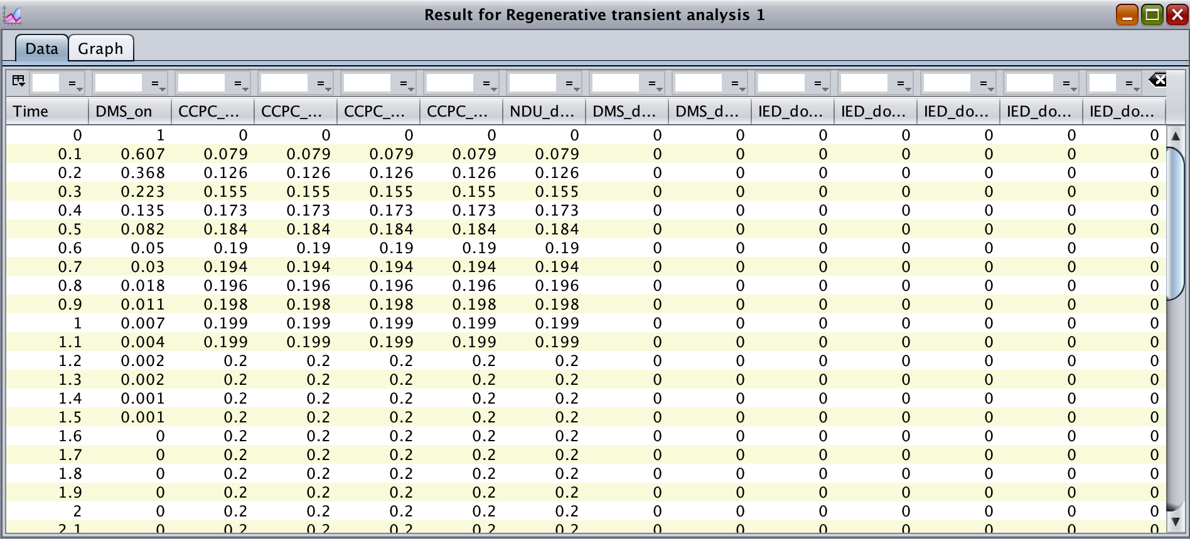

Fig.57 ORIS- numerical results of regenerative transient analysis

The panel that will open by default will be the *Data* panel, where the results are shown in numerical form. In the *Data* panel we have one row for each time instant, in which a result is calculated, and one column for each reachable marking. The value inside each cell will then represent the chance to be in the marking of that column after the time of that row given that we started at time 0 in the first marking of the model. For example, let's consider the fifth cell from the top and second from the left: this is telling us that given that we started from the marking *ready sending* at time 0, the probability that, after time 0.4, the model is still in that same marking (*DMS_on*) is 0.135. Clearly each row represents a probability distribution, meaning that the values in each row have to sum exactly 1.

Graphical results

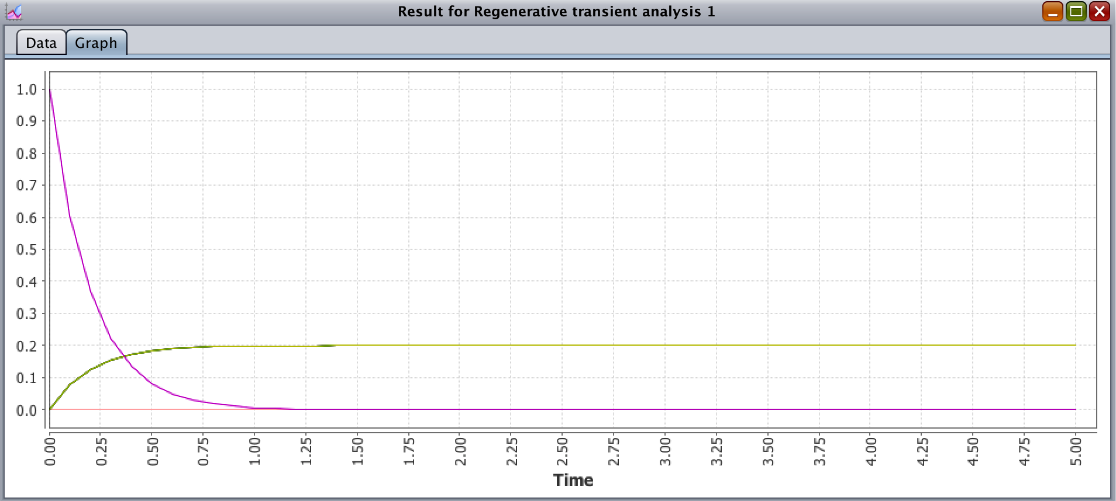

Fig.58 ORIS- graphical results of regenerative transient analysis

The *Graph* panel shows instead the graph built on top of the numerical results shown in the *Data* panel. More precisely, it shows a plot with several curves, where each curves correspond to a different column in the solution. These curves will vary depending on time, on the X-axis, and will show the corresponding probability value for that instant in time on the Y-axis.

Tip 4: You can hover on a curve to know which curve corresponds to which column.

Analysis with rewards

One last thing we can show in this section is how to specify rewards. Rewards are expressions on the model's states that represents certain behaviors of the model that particularly interesting to study. Here we use the following simple example:

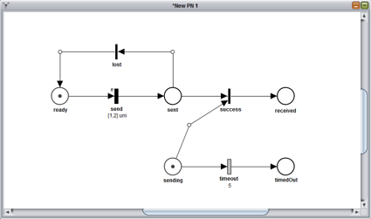

Fig.59 ORIS- a simple PN

Let's say we want to compare the probability of the model of having "decided" if the message is lost or not (i.e. being either in *received* or in *timedOut*) with the probability of still being uncertain about the message's fate (i.e. being in *ready* and *sending*). This measures are translated into rewards using a specific syntax and are defined as follows:

"If(ready==1&&sending==1,1,0); If(received==1||timedOut==1,1,0)"

If we enter this string into the *Rewards* field and rerun the analysis with the same values for the rest of the fields, we obtain the following graph:



Fig.50 ORIS- graphical results of analysis with rewards

We can see that these two curves are symmetric and sum 1 for every time instant, which means that the model is, at every moment, in one of the two described states: i.e. whether the message has been labeled or not as received/lost. We can also notice that the probabilities of the red curve (relative to the state *received OR timedOut*) are exactly the sum of the probabilities of the green and blue curve from the previous graph (respectively, the states *received* and *ready timedOut*).

GSPN analysis

Let's have a look now at the GSPN analysis, another feature offered by ORIS.

The GSPN analysis is an analysis just like the one we just saw, but for GSPN networks. A GSPN (Generalized Stochastic Petri Net) is a Petri Net with only immediate and exponential transitions.

Transient and steady state analysis

Let's use, for this example, the net "Simple GSPN" from the examples ([link](http://www.oris-tool.org/pns/simple_gspn.xpn)). Once you have it downloaded and open in ORIS, you can click on the  button. The various parameters in the analysis panel are exactly the same ones from the regenerative analysis we already examined, with the only exception of *Extended regenerations* being replaced by *Compute steady state*: while extended regenerations are not supported by the GSPN analysis, by checking this new option we can have the steady-state probabilities (i.e. as time goes to infinity) of the model calculated as a bonus and logged in the log of the analysis results.

For this example, let's choose a *Time limit* of 20 and leave the rest of the parameters with their default values. Once the computation is complete, we can see that, once again, the results are shown in the same manner of the regenerative analysis. If we open the graph tab we should see something like the following graph:



Fig.61 ORIS- graphical results of GSPN analysis

After a first transitory phase, we can see that the model reaches a steady state pretty soon. Clearly the probabilities for *P3* and *P4* are lower, since the execution flow of the model is split between the two after *P2*, with the probability of being in *P3* higher since the rate of its transition is lower than *P4*'s transition. Also we notice that *P2* is not listed, being a vanishing state. If you are interested in knowing the exact value of the steady-state probabilities for these three tangible states, you can rerun the analysis with *Compute steady* state checked and then open the log: the result should be 0.73 for *P1*, 0.18 for *P3* and 0.09 for *P4*, as you can see from this screenshot of the log:



Fig.62 ORIS- log of GSPN analysis

MRP steady-state analysis

The class of Markov Regenerative Processes (MRPs) is one of the most generic and broader classes of processes underlying a PN. Due to this generality, MRP cover more cases than other simpler abstractions, but they're also usually harder to analyze.

While MRP transient analysis is covered by "Regenerative transient analysis" feature in ORIS, steady-state computation can be efficiently achieved through the "Regenerative steady state analysis". This analysis, however, has the limitation of being usable only for those MRPs whose embedded DTMC in the regenerative states is *argotic*, i.e. irreducible, aperiodic and positive recurrent. So, for example, the "Transmission with Timeout" net wouldn't be analyzable with this method as the underlying process presents absorbing states and absorbing states are always reducible.

For this part of the tutorial, we'll then use the "Fischer's protocol" Petri Net. Once loaded into ORIS, let's click on the  button in order to configure the new steady-state analysis. For this analysis only a few parameters are available for configuration: it can be chose whether or not to include extended regenerations or to use the verbose logging mode and stop conditions and rewards can be specified. For this example let's say we want to evaluate the probability at steady state for a generic process to be either waiting to enter the critical section (a.k.a. latency) or inside the critical section itself. Being the Fischer's protocol symmetric, any of the three processes can be chosen, so it's correct to focus the analysis, for example, on the first process, thus leading to the following rewards:

"ready1+writing+waiting1; cs1"

It is worth noticing that the place *reading1* is not included as it is a vanishing state, providing no additional probability to the reward. Once the analysis is complete, we can open the result panel to see that the steady-state probability of being in the critical section *cs1* is *0.075*, while the probability of being waiting to enter in it is *0.131*. If the analysis is rerun including *idle1* in the rewards, it can be seen how the remaining probability is concentrated in *idle1*(*0.751* circa), meaning that most of the time a process is in idle mode, i.e. not needing to enter the critical section.

This PN representing the Fischer's protocol is very useful as a benchmark since much different analysis can be achieved using the ORIS regenerative steady-state analysis. A couple of examples can be to compute the occupation of the critical section by any process (using "*cs1+cs2+cs3*" as reward) or to evaluate how the latency of a single process ("*ready1+writing+waiting1*") varies when the characterizing parameters of the protocol, such as waiting or writing time, are changed.

Analysis under enabling restriction

Enabling restriction is the condition when, for a certain state of a PN, at most one GEN transition is enabled. If for every state of a given PN the enabling restriction is valid, the PN is then said to be *under enabling restriction*.

Analysis under enabling restriction is a different method to perform regenerative transient analysis, similar to the method based on stochastic state classes. The advantage is that, when analysis with stochastic state classes requires the condition of bounded regeneration to be met in order to perform it, analysis under enabling restriction requires a different condition. If we encounter a PN where bounded regeneration is not valid but enabling restriction is, it would still be analyzable thanks to this new analysis.

An example PN can be "Software Rejuvenation 2", from the examples section: in this model, the bounded regeneration is not valid (transition *tClock* stays enabled while the cycle of EXP transitions *tFProb-tDown-tUp* can happen infinite times) but the enabling restriction is (trivially demonstrated, since only one GEN is present in the entire model).

In order to start a new analysis we can click on the  button. For this analysis, parameters are as usual, except the *allowed error* which, in this case, represents the error allowed during the numerical evaluation of the embedded CTMC transient probabilities through uniform, and not the final error on the MRP transient probabilities.

For the sake of this example, let's choose a *time limit* of 400 and a *discretization step* of 10. The following picture shows the graphical results of this analysis:



Fig.63 ORIS- graphical results of analysis under enabling restriction

From the graphical results we can see how transient probability curves vary smoothly until the instant t=300, where many spikes are present: this is due the firing of the only GEN transition present, *tClock*, which is set as a DET transition with delay 300.